Contact: Dr Zuhaib Haider +60 163468369 zuhaib@utm.my
Dr Kashif Chaudhary +60 146337109 kashif@utm.my Dr Safwan bin Aziz +60137775755 safwanaziz@utm.my
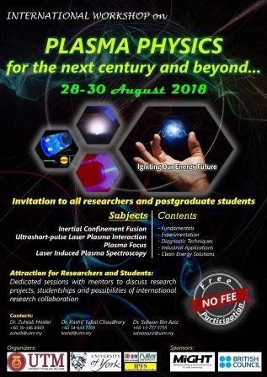
UTM Participants |  |  |  | Prof Dr Lee Sing  Prof Dr Saw Sor Heoh  Prof Dr Jalil Ali
York Participants |  |  |  | Dr John Pasley  Dr Kate Lancaster  Dr Chris Murphy  Prof Dr Greg Tallents
Program Plan
Day 1 (Tue: 28/08/2018)
9:00-9:30 |  |  | Opening
9:30-10:30 | Lecture |  | Prof Dr Lee Sing | Plasma focus: development and applications for industrial sector
10:30-11:15 | Lecture |  | Dr Chris Murphy | Laser-plasma interactions
Tea / Coffee Break
11:30-12:30 | Lecture |  | Dr Chris Murphy | Laser-plasma interactions
Lunch / Prayer Break
14:00-15:00 | Seminar |  | Dr John Pasley | Hydrodynamics driven by high-intensity, short-pulse laser-plasma interactions with solid targets
Tea / Coffee Break
15:20-16:00 | Seminar |  | Dr Kate Lancaster | Guiding of laser-produced fast electrons using super-strong magnetic fields
16:00-16:45 | Lecture |  | Dr Kashif Tufail | Arc Discharge Plasma
Day 2 (Wed: 29/08/2018)
9:30-10:30 | Lecture |  | Prof Dr Saw Sor Heoh | Plasma Focus: development and applications for energy
10:30-11:15 | Lecture |  | Dr John Pasley | Inertial Confinement Fusion
Tea / Coffee Break
11:30-12:30 | Lecture |  | Dr John Pasley | Inertial Confinement Fusion
Lunch / Prayer Break
14:00-15:00 | Seminar |  | Dr Chris Murphy | High intensity laser-plasma interactions: a route to high-field QED (Murphy)
Tea / Coffee Break
15:20-16:00 |  |  |  | Social Engagement (informal discussions)
16:00-16:45 | Lecture | Dr Zuhaib Haider |  | Laser Induced Breakdown Spectroscopy
Day 3 (Thu: 30/08/2018)
9:30-10:30 | Lecture |  | Dr Kate Lancaster | Alternative ICF schemes: a route to high gain (Lancaster)
Tea / Coffee Break
11:30-12:30 | Seminar |  | Prof Dr Lee Sing & Prof Dr Saw Sor Heoh | Demonstrating the plasma focus through numerical simulation.
Tea / Coffee Break
Recreational Activity

Closing Ceremony

