Regional Collaborative Workshop on Plasma Focus Diagnostic Development and
Applications RCWS 2011, 20 June to 1 July 2011

Notes for Hands-on Guided Experiments (to be read together with manual-attachment 1). This manual and most of the attachments are also available from www.plasmafocus.net

Session 1.

Plasma Focus Manual titled 3.3 kJ Plasma Focus Experiments (attachment 1).

Introductory Section of the manual; as follows:

Pg 1 describes the sections of the manual: Introductory; Work Schedule and technical appendices of advanced experiments

Pg 2 starts off with the Introductory section
1. Aim of facility: deuterium plasma for fusion
Extension: Neon plasmas for the production of soft x-rays
2. Plasma characteristics:
Extension: Neon at around 2-3 torr: Typically 1 J Neon characteristic line (He-like and H-like) Soft x-rays are emitted.

Pg 3 goes on to:
3. Block diagram of Sub-Systems: Capacitor bank discharging into the plasma focus through the spark gap. The spark gap is triggered by control electronics. Diagnostics systems include current coil, voltage probe and magnetic probes, G-M neutron counters, laser imaging systems and SXR spectrometric system (not shown). Complementary to these is the computer model code.

Pg 3a shows some photos of parts of the INTI PF; which may be viewed in the laboratory.

Pg 4 shows diagram of actual design of the PF tube and the capacitor and spark gap system; together with focusing signatures of current waveform (with dip) and voltage waveform (with spike) at around the time of peak current.

Pg 5 shows a sequence of laser illuminated images (ns time-resolved shadowgraphs) taken with a nitrogen laser shadow system. The correlation of the shadowgraphs (in time) with voltage waveform and time history of neutron and x-rays has been taken from a PhD thesis of a former student.

Pg 6 discusses the principle of operation. Even in those days (1991) we were pioneering the quantifying of plasma focus pinch dimensions in terms of the anode radius. Of course we have since moved on to the 5-phase model and we are now fitting current waveforms using the 6-phae model code.

Pg 7-14 go through the basics of the equations of motion coupled to the circuit equation; that form the basis of the Lee model code.

Pg 15 discusses the procedure for normalization and the scaling parameters resulting from the normalization procedure. If you have difficulty with the equations of pg 7-14 and the normalization procedure of pg 15; you will need to skip these for the moment and return some time in the future.

Note the last sentence which obtains the ratio of radial speed to axial speed as 2.5 which is the speed ratio (radial/axial) for the UNU ICTP PFF for Deuterium.

Note that this ratio does depend on specific heat ratio and radius ratio.
Note that for Deuterium sp ht ratio is effectively 1.67 whilst for neon and argon the sp ht ratio can be as low a 1.15 in the operation for soft x-rays.

Pg 17 gives the design parameters (bank parameters, tube parameters, operational parameters and the resultant characteristic quantities; also gives a depiction of what the plasma focus pinch looks like as an emitter of radiation and neutrons.

Pg 18-22 gives some of the solutions as modeled in 1991; using the numerical experiments technology of those days.

Session 2.

Second session of discussion on the plasma focus manual.

Pg 23 and 24 of the manual summarises the work schedule with briefing on the sub-systems making up the plasma focus.

Safety precautions are emphasized on pg 25.
Need to stress that the manual shorting rod must be visibly down except when the capacitor bank is being charged.

The control electronics discussed on pg 26 is still operational; and has proven its robustness after so many years.

If you want to know more about how the swinging cascade spark-gap works and also more about the gap settings; there is a detailed discussion in A Selection of Published Papers S Lee Vol II paper 29 (specialized knowledge; not important unless you wish to design spark-gaps).

Pgs 27 and 28 deal with the CRO triggering and synchronization. The basic principle is still correct, but with the use of DSO’s now the actual procedure will be slightly different. Triggering the DSO is far easier; and the DSO is usually triggered internally from the voltage probe attenuated by about 1000x. Moreover, all the 4 channels (for a 4 channel DSO) provide digital files which are all time-aligned.

Pgs 29-31 deal with the calibration of the current coil.
There is a recent paper in Rev Sci Instruments (attachment 2); the principal point of that paper is that the method described on pg 29-31 needs to be corrected by considering the motion of the current sheet even at high pressures.

There is another useful paper on the current measurement system (attachment 3) which has now been standardized for the INTI PF and for our collaborators at SAEC, Syria and KSU, USA. This paper discusses the Rogowski coil in its two configurations of measuring current directly and of measuring dI/dt from which is then integrated (either electronically or numerically) the current. The paper discusses the problem of noise and resonant modes and methods of dealing with these problems. The paper also discusses the frequency response of the coils. A final point made by the paper is that if a plasma focus current waveform cannot be fitted by the Lee model code, then that is an indication that that current coil has not measured the current waveform correctly, for any number of reasons.

Session 3: Hands-on Exercise to obtain information from voltage waveform

We look at Fig 6 on pg 32; and relate it to the voltage probe which is installed on the INTI PF. I refer NOT to the Tektronix high voltage probe but to the other one which is
installed on the INTI PF. This voltage probe is just a simple voltage divider using a resistor chain of 10 (500 Ohm) resistors all in series and in series with a 50 Ohm resistor; with the voltage across the 50 Ohm being measured by the DSO; usually via a 10x attenuator.

1 Voltage probe practical structure

The voltage divider (of 10x510 Ohm resistors) is pulled into a thick-walled plastic tubing (of the translucent water hose variety); this water hose is then pulled into a copper tube acting as the earth return and shield for the divider. Note the 51 Ohm that connects the low voltage end of the divider to ground.

2 Voltage probe attenuation factor

It is across this 51 Ohm resistor that the voltage is dropped (divided by ratio 51/5151) and taken to the DSO by a coaxial cable. In our particular arrangement the coax is then taken to a 10x attenuator (10x nominal) which has an input resistor of 50 Ohm into which the coax is plugged. This 10x attenuator had been tested and was found to have an attenuation factor of 12 times. The arrangement seems at first sight to reduce the input pulse by (51/5151)/12 =8.3x10⁻⁴ or an attenuation ratio of ~1200 times; but because the output resistor of the voltage probe may be considered to be in parallel with the input resistor of the attenuator (when the frequencies are not high enough for the connecting coax to exhibit purely transmission line effects); there could be another factor of 2; and the final attenuation factor of the system could be as high as 2400 times (rough estimate).

3 Voltage probe waveform- an example of what information may be obtained

The development of plasma diagnostics has come a long way with e.g. ns imaging techniques using short pulse lasers coupled to CCD recording devices. Complementary to these advanced techniques it is still important to have an understanding of the basic principles underlying plasma dynamics. For the plasma focus we have recently emphasized the importance of current measurements, a very basic measurement, yet the current waveform contains the information on all the energy processes happening in the various phases of the plasma focus, including the dynamics, thermodynamics and radiation. You will see the fundamental importance we place on the current waveform in session 4 when we fit computed current waveform to measured. The model code reveals realistic dynamics, thermodynamics and radiation properties of the plasma focus.

In this exercise we will look at the voltage measurement which we make across the input to the plasma focus tube. In principle the voltage measurement is related to the electric fields developed within the tiny pinch volume of the focused plasma during the radial pinch and post-pinch phases. We know from beam measurements that potential differences in the range of 100 kV and beyond are developed within the plasma pinch and post-pinch. However much of this occurs as electric fields within very small regions of space occurring over short time scales which unfortunately cannot be measured by limited response voltage probes (which in our case has a response time estimated as 15 ns) placed at the input flange of the plasma focus. Use of voltage measurements in this context awaits more sophisticated understanding, technology and development.

However the voltage measurement based on the simple basic limited response resistive voltage divider is very useful for understanding gross plasma dynamics. We already have a model code with the relevant circuit equations, essentially a voltage equation (incorporating energy and charge conservation), coupled to the equation of motion of the current sheath in the Lee Model code.

So the electro-dynamics (ie the current waveform and the current sheath trajectory as functions of time) in the axial phase is already completely described by the code. But the solutions produced by the code seem sometimes in a world of its own; and it could be difficult to come to grips with any part of it; since the whole may appear to encompass so many parts. What we are going to do now, is to look at one part of this whole picture to try to see the motion of the current sheet as we would understand a linear motor.

Moreover in the fitting process the axial phase involves two interactive parameters f_{c} and f_{m}. In the voltage method ‘b’ below, the f_{c} is determined without interactive influence. Hence this is a good method of fixing the value of f_{c}.

We are going to use a voltage waveform

- to obtain the axial transit time of the current sheet, hence to obtain the average transit speed and estimate the end-point axial speed.
- to measure the induced voltage of the motion and knowing the discharge current and the axial speed (measured in 1 above) obtain the fraction of current taking part in the axial motion.

Fig 11 on pg 32 of the manual shows a representation of typical voltage probe waveform correlated with the current waveform.

Note that the voltage across the tube rises up to a value and then drops as electrical breakdown across the tube occurs; also note that when the voltage has dropped to nearly zero, the current starts. The growing current interacts with its self magnetic field (in the azimuthal direction) producing a JXB force which pushes the sheet of current down the tube at a higher and higher speed as the current grows in value towards its peak. The
increasing current is seen in the current waveform of Fig 11. At the same time the voltage trace increases from near zero towards a humpy maximum, drops a little then spike upwards as the plasma current sheet reaches the end of the axial phase and implodes inwards in the radial phase, driven by the magnetic field which increases in value as the radius of the radial current sheet decreases.

The time it takes from breakdown (indicated in Fig 11 by the left-most dashed vertical line) to the start of the spike may be taken to be the time it takes the current sheet to travel the length of the anode (axial time-of-flight). The average axial speed may then be estimated.

4 An actual example (from series taken 16 Aug 2010 by Prof Saw; shot 1) at 11kV 1.5 Torr Neon

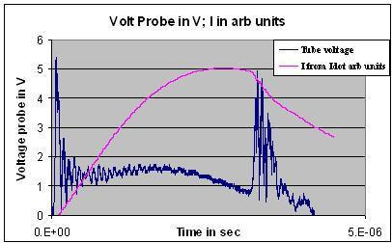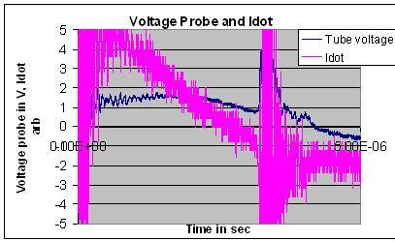
Fig 1 Fig 2

I also attach the original data and work sheet (attachment 4) so that you can work on the actual file.

4a End axial speed by time-of-flight:

From the voltage probe (Fig 1 or better still, measure from attachment 4) we note that the axial phase ends at 3.2 μs (since the radial phase starts at that time)
That is the current sheet has covered 16cm (length of the anode) in 3.2 μs
This gives an average transit speed of 16/3.2~ 5cm/μs)

The form factor for the speed is approx 1.5 for peak speed to average speed (which you may estimate from graph 2 pg 18 of the manual (peak speed/average speed~1.5)

From this time of flight estimate we have peak speed or instantaneous speed at end of radial phase~7.5 cm/ μs

[note: 1. this is an amazingly high speed; 75 km in 1 sec or 270,000 km/hr or Mach 250 ie 250 times the speed of sound in neon taken as 300m/s 2.The kinetic energy per particle imparted to the neon

ions at this high speed converts, through shock wave mechanisms, approx 50% into thermal energy giving a temperature of over 200,000K 3. All this information and more is obtained from just noting the time position of the voltage spike or equivalently the current dip. We have not even come to the voltage measurement yet!!! ]

4 b Voltage measurement- basic information

The voltage probe has its high voltage point attached to the anode collector plate and its low voltage point connected to the cathode collector plate of the INTI PF, represented in the following diagram:
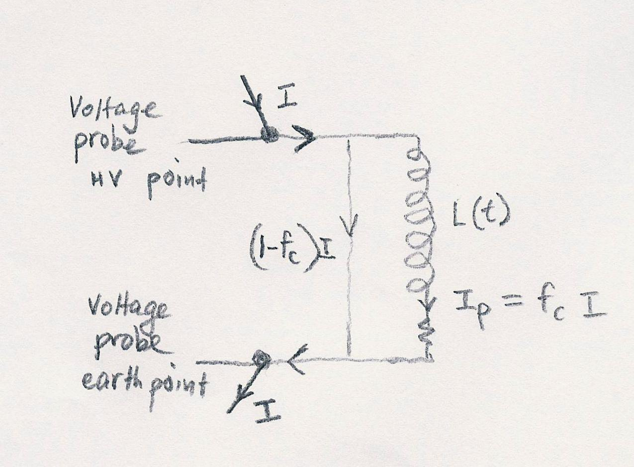
Fig 3: PF circuit, treating as a time-dependent inductance and a plasma resistance

In Fig 3, the capacitor current I enters the plasma focus tube. A fraction f_{c} (to be determined) of this current creates a current sheet driving it down the coaxial tube of the PF represented in the figure by the inductance L(t) and the resistance r_{p} (shown below L(t) but not labeled in the figure). There is a leakage current (1- f_{c})I flowing across the backwall of the tube also shown in the figure. The voltage probe monitors the voltage across the tube at the two points shown.

The voltage it monitors may be computed across the mesh L(t)- r_{p} as:

V=d(L_{t}I_{p})/dt +r_{p}I_{p}

where the current flowing into the plasma focus is I_{p}=f_{c}I; and we have f_{c} =axial phase current fraction, I is total discharge current flowing out of the capacitor and through the external circuit whilst I_{p} is the current flowing in the moving current sheath.

As the shock wave system develops moving faster and faster, the plasma conductivity rises, the electrical resistance of the current sheet drops. Our experience is that for the INTI PF, by the time the speed gets up above 5cm/us for deuterium (the current by then has risen above 50kA) its electrical resistance has become negligible.

For our present analysis we choose to look at a point when the current has reached its peak value of more than 100kA (for the INTI PF); so we feel confident enough that the second term (the current sheath resistive term) in the voltage equation is negligible when compared with the first term (the inductive term). In such a situation ie r_{p}I_{p} << d(L_{t}I_{p})/dt we have;

V= d(L_{t}I_{p})/dt = f_{c} d(L_{t}I)/dt = f_{c} I (dL_{t}/dt) + f_{c} L_{t}(dI/dt)

Choose a situation when Idot=0

To simplify the situation we may choose a point near or at peak current such that dI/dt =0 (see Fig 1 and Fig 2); which is particularly relevant in the plasma focus situation in which we usually reach the end of the axial phase at the time when the current is peak or near peak.

Choosing that situation we have:

V= f_{c} I (dL_{t}/dt); the other term being zero.

Check for consistency of voltage attenuation factor: which we have estimated (very roughly) as 2400 (see earlier)
Referring back to the start of section 3 which discusses Fig 11 of the manual; we will now interpret the first voltage spike near t=0 (see Fig 1) as the full capacitor voltage; ie we assume that on switching the anode of the PF rises to the full voltage (in this case 11 kV) before breakdown starts. This is an assumption that is not necessarily correct; as it is possible for the breakdown to start to occur even before the full voltage of the capacitor is imposed onto the anode.

[Nevertheless I have scanned through many sets of results and I have some confidence that we may make this assumption in this case. To be more certain we could run a series of shots at lower and lower pressures until breakdown becomes difficult, hence delayed. In that situation the voltage would rise to the full capacitor voltage hold for a noticeable time say a microsec before breakdown. The voltage waveform would then have a horizontal (constant value) section after its initial rise before dropping during the breakdown. We had used this method to calibrate the voltage probe in-situ; but do not recommend it since there is possibility of damage to probe or to the tube if the breakdown hold-off becomes too long].

The peak (pre-breakdown) voltage is 5.4V(refer Fig 1 or attachment 4) (note from the EXCEL sheet attachment 4 that the vertical scale for Channel 1 (the voltage Channel is 1V per division)
So we measure: 5.4 V= 11 kV
Then 1V~2040V; and we have an attenuation ratio of 2040; this is considered as a measured factor

I_{peak} and the voltage value at this time

I_{peak} for this shot is estimated as 140kA. (using the calibration constant of the coil determined earlier or we could get this value by fitting the computed current to the measured current)

We take the point 3.2 us when Idot =0 is measured from the data sheet (see Fig 2 above).
At this time the voltage signal (Fig 1) has a value of 0.8V which is 1630V (0.8x2040)

Estimating f_{c} the axial current factor

Now going back to the equation which applies to this point we have chosen when Idot=0:
V= f_{c} I (dL_{t}/dt);
We note that in a coaxial geometry such as we have in the INTI PF
L_{t}= [μ/(2π)] ln(b/a) z where z is the position of the current sheet; μ =4 π 10⁻⁷; b/a=3.2/0.95

So that L_{t} =2.4 nH per cm
Hence, dL_{t}/dt= 2.4x10⁻⁷x dz/dt so
V= f_{c} x I x2.4x10⁻⁷x dz/dt
Knowing the value of V, the value of I and the value of dz/dt estimated in para 4 above we can use these values to obtain the current factor (axial) f_{c} as:
f_{c} = 1630/[(1.4x10⁵)x(2.4x10⁻⁷)x(7.5x10⁴)]=1630/2520=0.65

Thus from the voltage waveform we obtain the axial current factor
f_{c} = 0.65

This is an important result; as f_{c} is a model parameter needed in the current fitting using the Lee Model code. The fitting typically obtains f_{c} as 0.7. So the value estimated from this exercise is consistent with our overall experience in such work.

5 Conclusion: Information obtained from Voltage and Current waveform

Position of focus spike or current dip gives the average axial speed, end axial speed

Value of voltage (at peak current) gives the axial current fraction f_{c}.

More on speed measurements

To measure the speed more accurately, we may monitor the time of arrival of the current sheet either using magnetic probes or luminosity detectors (photo-diodes, e,g, attached to fibre optic cables (which acts as collimators). There is a discussion of the magnetic probe pg 36-42- Expt 3 of the PF manual.
The speed is an important parameter; because once the speed is known, some ideas of temperature and density may be estimated using strong shock theory. This is discussed in Expt 4 of the manual.”

Session 4 Measurements of SXR.

We will now look at one method for the measurement of SXR for the INTI PF operated in neon.
We will use the technique of the 2-channel subtraction method for measuring SXR.
We will NOT go into the physical mechanisms governing transmission of radiation through various materials (that is an important area which you may wish to read by yourself one day).

We will try to focus just on the technique; which is based on the following:

- If we have a flat-response detector (ie one that detects with equal sensitivity over all wavelengths) then using such a detector we would be detecting and measuring radiations of all wavelengths.
- However each detector typically has its own sensitivity characteristics which is quantified by a response curve. The BPX65 (with glass window removed) which we use for these experiments has such a response curve.
- We also use filters to preferentially filter away selected wavelength (or equivalently photon energy) regions; and transmit in regions which we may wish to choose. For example in these experiments we wish to choose SXR regions; relevant to SXR which is produced specifically by Neon plasmas optimized in the INTI PF.

More details in the following note:

Filter pairs- Subtraction Method to measure SXR within a certain wavelength range

- Wavelength Range:

Question:
What is the wavelength range (or equivalently photonic energy range) we are trying to measure?

For neon PF, Liu’s work has shown that the strongly emitting SXR regions are: Liu PhD thesis pg 210 modified by Shan Bing’s thesis and other data discussed with Rajdeep:
(these theses are available on www.plasmafocus.net)
921eV: (13.447 A) 65% region 1 (strong line)
1020eV (12.132A) 15% region 2 (strong line)
1548-1070 eV (8-11.568A) 20% region 3 (lines & continuum)

b) The filters

b-1 Designed for subtraction method

The following filter pairs are designed for a subtraction method in the appropriate range.
The sensitivity of each of the two channels (with all factors folded in; ie with all factors accounted for) is shown in the following Chart. (supplied by NTU/NIE)

b-2 Sensitivity Curves (Excel data sheet is provided with details-see attached)
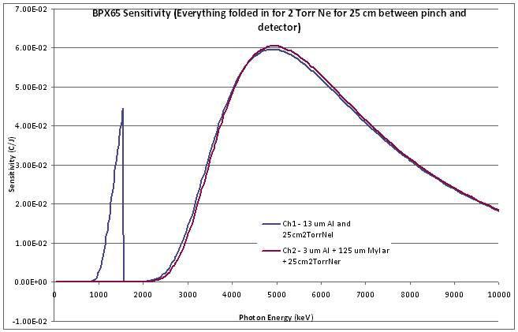
Fig. 4 Sensitivity curve of Ch1 and Ch2

There are 2 sensitivity curves in this Fig 4. (note horizontal scale is not keV but eV)

The 2 curves are: Ch1 13 um Al with detector BPX65
Ch2 3 um Al with 125 um mylar with identical detector BPX65

b-3 Subtraction (or Difference) Method

The two sensitivity curves are designed to be identical everywhere from very small energy (few eV’s) to very large energies (>10keV); EXCEPT in a very small energy range of 900eV to 1500eV.

Note: Channel 1 will detect well from around 2500eV to 10000eV
Channel 2 will detect (identically as Ch2) from 2500eV to 10000eV
Whatever Ch2 detects in the range 1500eV-10000eV is identically detected by Ch1.
Therefore subtracting outputs of Ch2 from Ch1 will cancel each other and produce difference=0, if the incident radiation is in the range 1500eV-10000eV

However Ch1 has an additional sensitivity zone in the range 900-1500eV which Ch2 does not have.
So when the output of Ch2 is subtracted from Ch1, if there is a significant difference it must come from SXR within the energy range of 900eV to 1500eV; which is detected by Ch1 but not by Ch2.

b-4 a Limitation of this particular combination of filters

Expanding the sensitivity curve for the range 700-1700eV we get Fig 5.

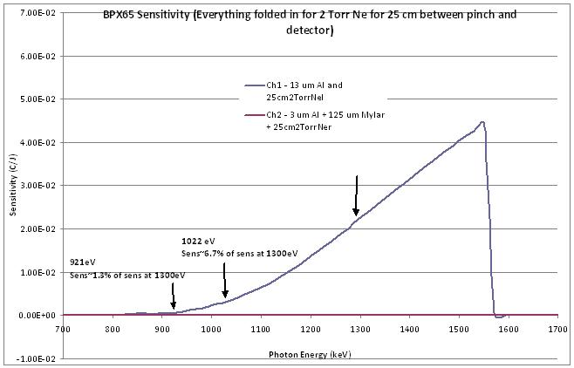
Fig 5 Expansion of Fig 4 to show the extra sensitivity spike of Ch1

This arrangement will detect region 3 (containing 20% of total SXR) in the above 3 regions of neon produced SXR as summarized in Liu’s careful PhD work. It will also detect region 2 (a strong line carrying 15% of SXR emission) but with poor sensitivity (contributing only 7.9% to area under the BPX65 signal) . Region 1, which contains the strongest line emission (65% of SXR emission), will also be detected at very poor sensitivity (contributing only 8.5% to area under the BPX65 signal) by this arrangement.

Despite the fact that our yield measurement is now disproportionately geared towards only 20% of the expected SXR’s, this method and arrangement is adequate to give a measurement of the SXR yield of Neon.

Practically all info and data on these two Channels are contained in the EXCEL worksheet (supplied by NTU/NIE Plasma Radiation Group) (attachment 5).

To get the Neon SXR yield, the difference of the areas of the signals from the two channels; ie Channel 1-Channel 2 (in V-sec) is keyed into the SXR Worksheet Sheet ‘xray3722’ (attached ) in cell AJ32; and the yield in joules appear in cell AC30.

Example

We discuss an example used in a recent paper submitted to IEEE Trans Plasma Sci (attachment 6)

Fig 6 shows that the computed current waveform is fitted very well to the measured current waveform, the two waveforms lying on top of each other appearing as one up to the point t=3.9 μs which is at the end of the RAN phases and the fitting is stopped. Fig 6 also shows the outputs of the two channels of SXR. The voltage waveform is not shown so as not to clutter Fig 6. The four measured waveforms are displayed on the same 4-channel DSO.

In Fig 6 the start and end of the computed Regular Dip RD from the 5-phase model are indicated by arrows. The anomalous resistance (RAN) regions lie past the end of the RD and extends to t=3.9 μs which is the end of the RAN region beyond which the fitting of computed and measured is stopped.

Fig 6 Correlating currents and SXR channels. The computed current is fitted so well to the measured current that the two traces overlap, appearing as one trace (the top trace). The SXR Ch1 and the SXR Ch2 also overlap very well except the first pulse (just after 3.4 μs) which is dominated by Ch1. Ch1’s output is also slightly bigger than Ch2 for the second pulse; but the third pulse and very large fourth pulse (appearing just before 3.8 μs) have the outputs of Ch1 and Ch2 inseparably overlapping.

Fig 7 This is an expansion of Fig 3 from 3.3 to 3.9 μs. The top trace running across the figure is the overlapped lines of the computed and measured currents. The SXR Ch1 and Ch2 also overlap very well except the first pulse (just after 3.4 μs) which is dominated by Ch1. The 3 vertical lines are time markers for (from left) start of radial phase or RD, start of pinch phase and end of pinch phase which is also end of RD.

Fig 7 is an expansion of Fig 3 for the region 3.3 to 3.9 μs. It shows the outputs of the two SXR channels. From this Fig 4 we see that the first SXR straddling the pinch duration is predominantly characteristic neon SXR (since there is a difference pulse). After the pinch phase there is the short (few ns) RAN1 phase which coincides with the tail of the characteristic neon SXR pulse. The 3 RAN sub-phases are indicated by the thin red line running across near the bottom of Fig 7; the first RAN sub-phase is of very short duration shown by the almost vertically dropping thin line just after the end of the pinch phase. (seen more clearly in the more highly expanded Fig 8). Towards the end of the RAN2 phase (see Fig 7) there is a sharp SXR pulse with a duration of less than 10ns. This pulse is harder SXR than the characteristic neon SXR lines as is evidenced by the fact that the SXR Ch1 and Ch2 have almost identical outputs over the duration of this pulse, so that the difference of the two Channels is practically zero. Then at the start RAN3 there is a similar SXR pulse of slightly higher amplitude but larger pulse duration of about 40ns. The difference of the two Channels over this pulse is also nearly zero which indicates that the photon energy of this pulse is primarily harder than the characteristic neon SXR. Finally between 3.6 to 3.7 μs the main SXR pulse of this shot is emitted with a much larger amplitude (two times bigger) and a larger duration (close to 100ns). This is the major SXR emission of this shot and the emission is not characteristic neon SXR but is a harder SXR possibly from Bremsstrahlung coming from the fully ionized neon plasma of the type observed by others [22]

Fig 8 This is derived from Fig 4. The top trace running across the Fig 5 is the overlapped lines of the computed and measured currents. The pulse shown in this figure is the characteristic He-like and H-like neon SXR pulse obtained by subtracting Ch2 from Ch1 (see Fig 4). The 3 RAN sub-phases are indicated by the thin line running across near the bottom of Fig 5.

Fig 8 is derived from Fig 7 and shows the correlation of the measured (and computed) current with the characteristic He-like and H-like neon SXR which is the difference pulse obtained by subtracting SXR Ch2 from SXR Ch1 of Fig 7. Also shown in Fig 8 are time markers (vertical dashed lines) indicating from the computed results the start of the radial phase, the start and end of the focus pinch phases. The RAN sub-phases are also indicated by the anomalous resistances (denoted by the light line in arbitrary units).
The results show (for this particular shot) the characteristic neon SXR starts strongly some 10 ns before the pinch phase, the pulse dropping in amplitude through the 10 ns duration of the pinch phase and continues to drop to zero for another 5 ns after the pinch phase into the first anomalous resistive (RAN) phase. There is little or no characteristic neon SXR beyond this single pulse of SXR which lasts some 25 ns in total duration, straddling the 10 ns pinch phase. This characteristic He-like and H-like neon SXR pulse for this shot is integrated and found to have a radiation yield of 1.1 J.

Session 5 A Template for the fitting of computed current waveform (Lee model code) to measured current waveform and to correlate computed plasma dynamics with measured SXR pulses

We have developed a template to be used with the 2 channel subtraction method. The method required the recording of 4 channels of data these being:
Tube voltage
SXR Ch1 BXP65 filtered by 13 um Al and protected by 3 um mylar
SXR Ch2 BPX65 filtered by 3um Al and 125 um mylar
Idot

The template is provided as an EXCEL Workbook. (attachment 7)

The Workbook has 4 Worksheets
Sheet 1 is the Lee Model code (6-phase)
Sheet 2 displays additional data, acts as diagnostic reference
Sheet3 is the fitting and correlation sheet
Sheet 4 shows how to put the 5 columns of data together for transfer to Sheet 3.

The five columns are (The graphing has been specified for 10,000 points of data per column; if more data points are required go the source data and adjust):
Column C: time in seconds
Column D: Voltage from 100:1 divider via 10x attenuator
Column E: SXR Ch1 Al filter
Column F: SXR Ch2 Mylar Filter
Column G: Idot signal for 7-turn coil.

These 5 columns C-G are copied and pasted to Columns C-G of the correlation sheet 3.

Description of correlation worksheet 3.

Tube voltage data is manipulated in columns K and L, outputted in L with a scaling factor in A19 to enable it to be plotted in the most presentable (cosmetic) manner.
SXR Al data is manipulated in Columns M,N and outputted in N with a cosmetic scaling factor at A20. Column M contains the original unscaled SXR data as inputted in E.

SXR Mylar data is manipulated in Columns P, Q and outputted in Q with a cosmetic scaling factor at A20. Column P contains the original unscaled SXR data as inputted in F.

dI/dt data is manipulated in Column T, integrated in Column U and outputted in Column V as a current with a scaled (calibration) factor in cell A18. The scaling factor is adjusted during the current fitting process until the peak of the measured current profile agrees with the peak of the computed current profile. The computed current profile simulates the same capacitor bank using charge and energy conserved equations. When the measured and computed current amplitudes are adjusted to fit and if then the computed current profile and the measured current profile also fit then this method of adjustment of the measured current peak is deemed to be a calibration.

The characteristic neon line SXR yield is computed as follows.

Column M data is integrated and presented in Column O giving the area under the SXR pulse profile (the original unscaled pulse) as detected by the Al filtered diode

Column P data is integrated and presented in Column R giving the area under the SXR pulse profile (the original unscaled pulse) as detected by the Mylar filtered diode

Column S gives the yield of the characteristic neon line SXR by taking the difference of Column O and Column R and taking into account the following:
Geometrical factor of the pin diode detection area and the distance of the detection surface from the SXR emitting region;

Alternative use: Fitting current only:
We may just replace Column C and Column G with the data for a new shot; and leave Columns DEF untouched. Then the SXR data is irrelevant
And we just fit computed current to measured current; using Fig 1 and Fig 2 to assist in the fitting; ignoring the SXR signals.

Procedure for fitting current and correlating SXR pulses

- Copy data sheet into the sheet after s7; say s8
- Format the data as per example given in s7 into 5 columns.
- Copy the 5-column data from the data sheet s8 and paste into Column C-G of s7a; rename s7a as s8a. The new data appears in the Figs 1-4
- Go to Sheet1; configure for the PF of s8; and run
- The computed current is automatically transferred to s8a, Figs 1,2,4

- Fit the computed to measured current, initially using Fig 1; use the following procedure

a. Use the time shift factor Cell A17. This quantity in A17 is a time alignment amount which accounts for non-ideal switching characteristics of the measured current when fitting the measured current to the computed current which does not have these switching characteristics.
Use the current factor cell A18 to help in the fitting. The scaling factor is adjusted during the current fitting process until the peak of the measured current profile agrees with the peak of the computed current profile. The computed current profile simulates the same capacitor bank using charge and energy conserved equations. When the measured and computed current amplitudes are adjusted to fit and if then the computed current profile and the measured current profile also fit then this method of adjustment of the measured current peak is deemed to be a calibration.

b. After adjusting A17 and A18 to help with the fitting, next step is to fit the axial phase varying fm and f_{c} (typically f_{c} taken as 0.7). Note that increasing fm would slow the computed axial speed, reducing the time to the current dip, and vice versa. Several adjustments may have to be made, each time numerically firing a shot. When fm is adjusted properly the computed and measured current trace will overlap up to the start of the radial phase which is indicated approximately by the start of the current dip. (see Fig 1 and Fig 2 of the correlation worksheet.)
When the currents are satisfactorily fitted up to the start of the current dip we may proceed to fitting the radial phase.

c. This phase is fitted by adjusting f_{mr} (preferably keep f_{cr} at 0.7). Note that increasing the value of f_{mr} reduces the slope of the current dip and the extent of the dip. Decreasing the value of f_{mr} tends to increase the slope and extent of the dip. Again several adjustments may need to be made to obtain a satisfactory fit. During these adjustment to the radial phase it may be necessary also to go back to make very tiny adjustments to the value of f_{m}. Finally the fit of the currents should be good as far down the current dip as the fitting would go.
There are 3 vertical lines time indicators which will shift about automatically as the model parameters are adjusted and the numerical shots are successfully fired. These 3 vertical lines are from the left: the start of radial phase (or start of RD); the start of pinch (or slow compression phase) and the end of pinch (which is also the end of RD) and start of RAN1.

d. When the currents are satisfactorily fitted up to the end of the pinch go to the RAN panel on sheet 1 and start fitting the first anomalous resistance phase by adjusting the values of RAN1 parameters; these being for RAN1 R0 in Cell J11, tou2 Cell J12, tou1 Cell J13 and end fraction in cell J14. Note that R0 will control the slope of the computed current for phase RAN1, tou1 controls the rise time of the anomalous resistance, tou2 the fall time which is truncated by the end fraction. As usual each adjustment is tested by numerically firing a shot.

- When the first feature in the measured current beyond the pinch is satisfactorily fitted, then go the second feature which will be fitted by the RAN2 parameters in cells K11-K14.

- After the second feature is fitted go to the third feature and use parameters in cells L11-L14.
Each RAN1 and RAN2 feature typically lasts for 30-50 ns; whilst RAN3 feature may be longer up to several hundred ns.

- Note that final careful fit is done with the help of Fig 2 (expanded time scale looking at the radial region only. May be necessary to decide from Fig 1 the time range for the radial phase and re-adjusted time range of display of Fig 2.

- After final adjustments to the fitting of the current traces, go on to compute dJ, the energy of the characteristic SXR lines of neon. Use the following procedure.

- Determine from Fig 1 (with the help of Fig 2) the time of start of the first SXR pulse, say 3.215 μs; look at column J which is the relevant adjusted time which is displayed in the Figs 1-4. Scroll down until Column J reads 3.215, then type in 0 (zero) for the cell O & R corresponding to that line (J 3.215).
This resets dJ to zero so the integration of the SXR signals start from this point.

- Figure 3 then traces dJ, the peak value of which is read off using the cursor. The time of integration from dJ=0 to this peak dJ is noted. The dJ curve is traced to a stretch where the SXR pulse contributes no more to the integration. From this stretch, the droop of the dJ curve is worked out (there should be no droop, and any droop is due to baseline shift). If the droop is say 1.2 mJ per ns and the integration time from dJ=0 to dJ=peak is 70 ns, the correction that needs to be added to dJ peak value is 70x1.2J=84 mJ.

Information provided by the Template analysis include the following:
1: How the computed current fits the measured current; axial phase, radial RD and the RAN1,2,3 phases
2. The yield of H-like He-like characteristic neon SXR line from measured data
3. The correlation of the SXR pulses (characteristic line and harder Bremsstrahlung to the various phases, pre-pinch (Reflected Shock), pinch, RAN1, RAN2, RAN3
4. computed trajectories axial and radial, averaged temperatures, densities
5. fitted mass factors and current factors and parameters of the anomalous resistances 1, 2 and 3.

Note on the SXR yield calibration factor:
The SXR yield calibration factor for characteristic neon H-like and He-like lines for the template has been computed for the set up of the INTI PF (including detector position relative to emitting source.
For another setting the calibration factor may need to be re-calculated.
It is not necessary to change the calibration factor of the current coil. No
calibration factor is used. The computed curve (which is charge consistent) is fitted to the measured. One of the points of the fitting is the point of peak current. Thus the fitting automatically calibrates the measured current waveform in a charge-consistent manner. This is found to be the best method.

A Hands-on Example:

We provide the data of a shot taken on April 12 2011:
INTI PF 12 kV Neon 2 Torr (attachment 8)

Electrical and tube parameters of the INTI PF are given in the first row of following table; and operational parameters are given in the last row
The middle row give typical model parameters for INTI PF operating in neon
Lo nH | Co uF | b cm | a cm | zo cm | ro mOhm
114 | 30 | 3.2 | 0.95 | 16 | 13
massf | currf | massfr | currfr | Model Parameters
0.0365 | 0.7 | 0.12 | 0.7
Vo kV | Po Torr | MW | A | At-1 mol-2 | Operational Parameters
12 | 2 | 20 | 10 | 1

Using the Template we will work together with the data for this shot, following above procedure step by step

Steps 1-6 of above Procedure for fitting current and correlating SXR pulses
;
step 6 sub steps a-j

