**Suitability of using Lee Codes to fit a Mather, Fillipov and Hybrid Dense Plasma Focus Machines current waveform.**

**Arwinder Singh1, Teh Thiam Oun1, Saw Sor Heoh2,3 and Lee Sing1,2,3**

1*INTI International University, Persiaran Perdana BBN, Putra Nilai,71800 Nilai, Negeri Sembilan, Malaysia*

*2Nilai International University, No 1, Persiaran Universiti, Putra Nilai, 71800 Nilai, Negeri Sembilan, Malaysia*

*3Institute for Plasma Focus Studies, Chadstone, VIC3148, Australia*

**Abstract**

There are several types of Dense Plasma Focus (DPF) machines with different anode geometry. It is a real advantage if the various types of machines could be simulated using one code. This is of particular importance from the comparative point of view. This paper examines the use of the Lee Code to model a Mather type Plasma Focus(PF), a Filippov type PF and a hybrid type PF. The test for model fit is to check if the computed current waveform could be fitted to the measured current waveform. It is found that the Mather type PF is modelled well and that the hybrid PF is also fitted well. The Filippov type PF could be fitted only for the lift-off phase and the first part of the pinch phase using the standard Lee Code, although it has been reported that a different code called the ML (Modified Lee) has been developed and is used to fit Filippov typed PF’s. The conclusion is that the Lee Code in its current form can be used to model Mather type PF and hybrids, but needs extensive modification such as to Siahpoush’s ML version in order to accurately portray all phases of the Filippov type PF.

**Keywords:** Numerical experiment, dense plasma focus, Mather, Fillipov, Lee model code

**Introduction**

Ever since the industrial revolution, the demand for electrical power has increased tremendously. With the ever depleting amount of petroleum, gas and coal sources, the need to find a long-term source of energy is of extreme importance (S Lee et al 2011). Controlled nuclear fusion is one of the alternatives as it is environmentally friendly and practically inexhaustible. To understand fusion reaction, dense plasma focus devices have been built in various parts of the world and studies have been carried out on high energy density nuclear fusion in plasmas as well as applications with fusion neutrons and with other emissions from high density plasmas in various gases.

The plasma focus machine has two distinct electrode geometries named after their founders (J W Mather (J W Mather 1960) during his research with the Marshall Gun in United States and independently by N. V. Filippov (N V Filippov et al 1962) at Kurchatov Institute, Russia in the early 60’s). The obvious differences are in the electrode dimensions and the diameter to axial length aspect ratio of the inner electrode as shown in Figure 1. A Mather type Plasma focus has a small aspect ratio (anode radius/anode length) of typically 0.25 or below, with an inner electrode (anode) diameter typically of between 2 to 22 cm. A Filippov type plasma focus, on the other hand has a large aspect ratio, typically greater than 5 with inner electrode (anode) diameter in the range of 50 to 200 cm.

For plasma focus machines to operate and scale efficiently, the configurations and parameters of each machine have to be designed and adjusted within a range not too far from an optimum (efficient performance range). This can be done through numerical experiments using a proven code such as the Lee code; as has been the case with several existing machines. Many existing machines have also been designed in the following way: starting with available capacitor bank (bank parameters capacitance C0, maximum charging voltage, circuit static inductance L0 and circuit stray resistance r0), experimenting until tube parameters are decided upon (tube parameters: anode radius ‘a’; cathode radius b; anode length z0 and then experimenting with the operational parameters (charging voltage V0, gas type and gas fill pressure P0). The combination of the above parameters within an efficient performance range for each machine will produce plasma parameters which are suitable for the efficient production of radiations or plasma streams, depending on the objective or applications of each machine.

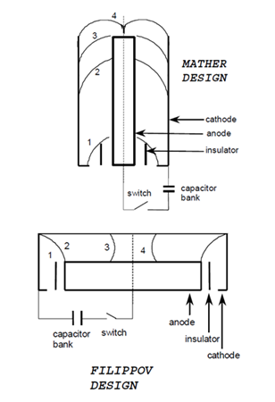

|  |  |
| --- | --- |
| Figure 1 | Mather and Filippov type Dense Plasma Focus devices schematic drawing (A Bernard et al 1998 and S Bing 2000). |

The working concept of the Dense Plasma Focus is as follows: the energy stored electrically in a capacitor bank is quickly discharged to the electrodes by means of a fast switch. In both Mather and Filippov type devices, the current discharge starts along the surface of the insulator in a coaxial electrode region (shown as ‘1’ in Figure 1). By the Lorentz force action, the conducting plasma sheath quickly travels from position 1 through position 2 to position 3. In position 4 the shock wave preceding the sheath reaches the axis of symmetry of the electrodes. To optimize the machine, the machine designer chooses the dimensions of the electrodes (length and diameters) and the operational pressure in relationship with the characteristics of the energy source so that the current is maximum when the shock wave reaches the axis. Following this, a filament of hot and dense plasma (pinch) is formed in front of the inner electrode (usually the anode). After a very short time due to instabilities the plasma column breaks up and decays (A Bernard et al 1998, S Bing 2000 and M Krishnan 2012).

Similarities in these devices are in: (1) the dynamics of the current sheath, (2) the neutron emission scaling laws and (3) the release of ions and electron beams, x- rays etc.

**Objective of this Research paper**

With the ever increasing number and types of dense plasma focus machines and anode geometry all over the world, the performance of these machines comes into question. Will the numerical experimental codes in particular the Lee code be able to model all this machine current waveform, so that the designer or user of this machine able to understand its plasma dynamics?

This is because according to the paper publish by Lee and Saw (S Lee et al 2010 a, 2017), the current trace should be analysed because it contains information on the dynamic, electrodynamic, thermodynamic and radiation processes that occur in the various phases of the plasma focus (S Lee 1984a,1985a). Thus, one of the most important procedures is to connect the numerical experiment using Lee codes (S Lee 2014 a) to the reality of the actual machine is by fitting the computed current trace to a measured current trace (S Lee et al 2008, 2009 a, 2009b, 2010a, 2010 b, 2012 and S H Saw et al 2010 a, 2011).

**Methodology Used**

In this paper, the Lee 5/6 phase code will be used to fit a Mather, a Fillipov and a hybrid machine. S Lee introduced a 2-phase (axial and radial) model (S Lee et al 1984 b,1985 b) in 1983 which became a component of a 3 kJ plasma focus experimental package known as the United Nations University/International Centre for Theoretical Physics Plasma Fusion Facility (UNU/ICTP PFF) (S Lee et al 1998, 2017). This model was later modified into a 5/6-phase radiative plasma focus model which is now widely known as the Lee Model code (S Lee 2014a, 2014b). It has been reported that a model based on the Lee model, the so-called ML (modified Lee) has also been developed by Siahposh (V Siahpoush et al 2005) and is used to successfully model Filippov type PF’s, using the current fit method pioneered by the Lee model code.

The physical basis, the structure of the model, the results and extensive scope of the code is shown in Figure 2 (S Lee 2012 a, 2014a, 2014 b).

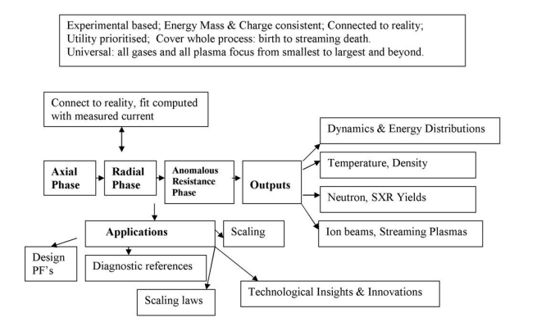

|  |  |
| --- | --- |
| Figure 2 | The physical basis, structure, results and extensive scope of the Lee Model code ( S Lee 2012 a, 2014a, 2014 b and S Lee et al 2017). |

**Results and Discussion**

In the first case, the Lee model code was used to fit the current waveform of a Mather type machine namely INTI Plasma Focus (INTI PF) machine working at 2.0 Torr in neon gas. This machine is a machine of the UNU ICTP PFF network.

Figure 3 shows the fitting uses Lee Model 5-phase code [shown in Table 1] to fit the current waveform of INTI Plasma Focus machine. It has been shown that the Lee Model 5-phase code does fit the computed current dip to the first part of the measured current dip. But there is an extended part of the measured current dip attributed by the anomalous resistivity (due to large amount of remnant inductive energy that is transferred to instabilities) which cannot be fitted by the computed current dip no matter how the model parameters are varied

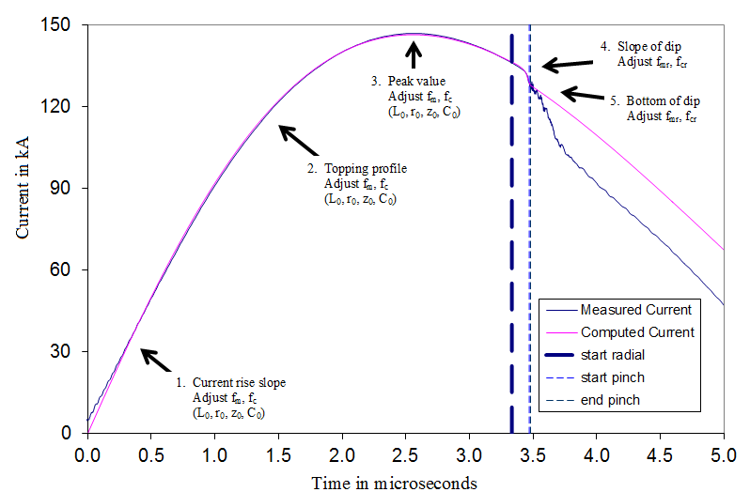

|  |  |
| --- | --- |
| Figure 3 | The 5-point fitting of current trace to the measured current trace obtained from INTI Plasma Focus (INTI PF) machine fired at 2.0 Torr in neon gas. |

Thus, Lee Model 6-phase code has to be used. The Lee Model 6-phase code has an additional phase between the end of pinch and the expanded column phase. This additional phase is fitted by adding anomalous resistance terms into the circuit equation (typically 3 sequential anomalous resistance terms). Adjustments are made to the amplitude of each anomalous resistance terms and also the rise and fall time characteristics until a good fit is obtained down to the bottom of the measured current dip [shown in Table 2].

|  |  |  |
| --- | --- | --- |
| Table 1 | The actual machine, operational and fitting parameters configured for the INTI Plasma Focus. | |
| Capacitance C0 (µF)=30  Static inductance L0 (nH)=114  Circuit resistance r0 (mΩ) =13  Cathode radius ‘b’(cm) =3.2  Anode radius ‘a’(cm)=0.95  Anode length ‘z0’(cm)=16  Charging voltage V0 (kV)=12  Fill pressure P0 (Torr)=2 | | Fill gas (molecular weight) =20  Fill gas (atomic number) =10  Fill gas(atom)=1  The fitted model parameters are:  Axial phase mass factor, fm=0.0408  Axial phase current factor, fc=0.75  Radial phase mass factor, fmr=0.41  Radial phase current factor, fcr=0.78 |

|  |  |
| --- | --- |
| Table 2 | An example of the values of the anomalous resistance used to fit the INTI Plasma Focus current waveform for Figure 4. |

|  |  |  |  |  |
| --- | --- | --- | --- | --- |
|  | R0(Ω) | Characteristic of fall time τ2 (ns) | Characteristic of rise time τ1 (ns) | End fraction time |
| Dip 1 | 1 | 25 | 5 | 0.2 |
| Dip 2 | 0.14 | 100 | 20 | 0.5 |
| Dip 3 | 0.36 | 120 | 25 | 1 |

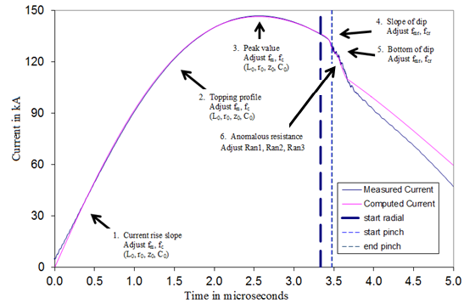

|  |  |
| --- | --- |
| Figure 4 | The 6-point fitting of computed current trace to the measured current trace obtained from INTI PF machine fired at 2.0 Torr in neon gas. |

In Figure 4, point 1 shows the current rise slope. Point 2 shows the topping profile. Point 3 shows the peak value of the current. Point 4 shows the slope of the current dip. Point 5 shows the bottom of the current regular dip (S Lee et al 2010 a, 2010 c) while point 6 is the instability region. Fitting is done up to point 6 only.

The Lee Model 5 and 6-phase code has been shown to describe the Mather Plasma Focus very well. In other words, the physical mechanisms assumed in the modeling: an axial phase described by a snow-plow model with fittable fm and fc; and a radial phase of an accelerating and elongating plasma slug with fittable fmr and fcr; appear to be adequate to represent the Mather Plasma Focus at least in the gross mass-consistent, energy-consistent and charge-consistent sense.

In the second case, Lee code was used to a fit the current waveform of a Filippov type machine namely PF3 machine (V I Krauz 2010) working at 1.5 Torr in neon gas. It was found that the Lee Model 5 and 6-phase code could not fit this Fillippov Focus, but important information about the radial dynamics of this Filippov Focus could be obtained.

|  |  |  |
| --- | --- | --- |
| Table 3 | The machine, operational and fitting parameters for PF3 Plasma Focus machine. | |
| Capacitance C0 (µF) = 9200  Static inductance L0 (nH) = 40  Circuit resistance r0 (mΩ) = 1  Cathode radius ‘b’ (cm) = 58  Anode radius ‘a’ (cm) = 50  Anode length ‘z0’ (cm) = 2  Charging voltage V0 (kV) = 9  Fill pressure P0 (Torr) = 1.5 | | Fill gas (molecular weight) = 20  Fill gas (atomic number) = 10  Fill gas (atom) = 1  The fitted model parameters are:  Axial phase mass factor, fm = 0.025  Axial phase current factor, fc = 0.7  Radial phase mass factor, fmr = 0.03  Radial phase current factor, fcr = 0.5 |

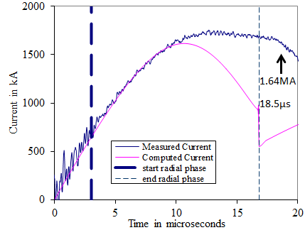

|  |  |
| --- | --- |
| Figure 5 | Measured current waveform of Filippov PF3 Plasma Focus at 9 kV, 1.5 Torr neon gas compared with Lee Model 5-phase code computed current waveform. |

|  |
| --- |
| Note: The digital waveform for shot 4102 was obtained from Mitrofanov Konstantin and Krause Slava on 3/5/2011 who are the authors of reference (V I Krauz 2010). |

From Figure 5, it can be noticed that the ‘axial’ phase could be fitted reasonably well. The radial phase was also very well fitted up to 9.6 µs (when the shock-piston slug was at 36 cm in its inward radial motion)- see attached Figure 6 (below); the timing and position are worked out from Figure 5 from the time of the start of the radial phase.

The results of the fitting revealed that the Filippov PF3 can be fitted by the Lee Model 5-phase code by varying fm and fc for its very short ‘axial’ phase and by varying fmr and fcr in its radial phase from 50 cm to 36 cm. Beyond that the Lee Model code assumes a well-defined slug motion (of shock front and magnetic piston) which fails to describe the progression of events in the PF3. The measured current continues to rise to 1.7 MA at 12.7 µs then flattens out with a flat droop to 1.64 MA at 18.5 µs. The best computed fit sees the current peaking at 1.62 MA at a 10.6 µs then dropping with a relatively steep slope to a value of 0.95 MA at 16.7 µs before a final abrupt dip caused likely by the radiative collapse mechanism (S Lee et al 2013) which has been built into the Lee Model code.

The divergence of computed to measured waveform can be interpreted as follows: The PF3 can be modeled by a slug-like compression of the plasma up to 36 cm and then that slug-like behaviour is no longer a valid description. From the current trace of this shot the flattening of the current trace (instead of sharply dipping) indicates that the inward piston- driven plasma slug motion gives way, probably to some form of plasma diffusive mechanism.

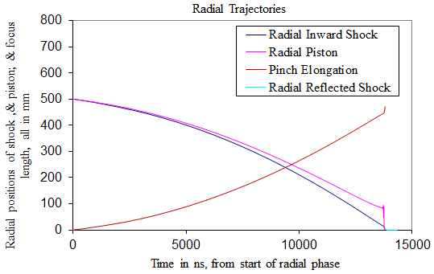

|  |  |
| --- | --- |
| Figure 6 | Radial trajectory of Filippov PF3 according to the Lee Model 5-phase code; taken from same numerical shot as Figure 5. |

It can be noted, that based on the measured current traces of PF3 it can be concluded that the PF3 Filippov PF agrees with the Lee Model 5-phase code in its lift-off phase but diverges from the Lee Model code dramatically in the crucial late radial and pinch phases.

In the third case, the hybrid type plasma focus machine namely the Nano focus machine will be fitted with the Lee model code.

The Nano Focus is a hybrid machine (0.25 < aspect ratio < 5) operated with 0.1-0.2 J in energy with an anode 0.8 mm in radius and a length of half mm (S H Saw et al 2010 b) constructed at the Chilean Nuclear Energy Commission. It uses a pair of 200 mm diameter brass electrodes which acts as a capacitor to drive the discharge. The device uses an anode of 0.8 mm radius working in hydrogen at 6.5 kV. It was found from Lee Model 5-phase code that, in order to achieve a satisfactory fit, the effective anode length was 0.025cm instead of 0.04cm as stated in reference (L Soto et al 2009).

|  |  |  |
| --- | --- | --- |
| Table 4 | The machine, operational and fitting parameters for the Nano Focus machine. | |
| Capacitance C0 (µF) = 0.0049  Static inductance L0 (nH) = 4  Circuit resistance r0 (mΩ) = 300  Cathode radius ‘b’ (cm) = 0.15  Anode radius ‘a’ (cm) = 0.08  Anode length ‘z0’ (cm) = 0.025  Charging voltage V0 (kV) = 6.5  Fill pressure P0 (Torr) = 2.25 | | Fill gas (molecular weight) = 2  Fill gas (atomic number) = 1  Fill gas (atom) = 1  The fitted model parameters are:  Axial phase mass factor, fm = 0.029  Axial phase current factor, fc = 0.7  Radial phase mass factor, fmr = 0.042  Radial phase current factor, fcr = 0.96 |

This hybrid machine has static inductance L0 of 4 nH (Obtained from Lee Model 5-phase code instead of 4.8 nH as stated in the reference (L Soto et al 2009)). The Lee Model 5-phase code was used for the fitting. It was found that the code needed to be modified at step 4000 where D = Dreal/10^9 was used instead of Dreal/10^8 in order to divide the radial phase into 10x smaller steps. This step is needed because the scale of the machine (in both geometrical and temporal dimension) is considerably (more than 10-fold) smaller than any machine fitted so far using the Lee code. The fitting current obtained is shown in Figure 7.

|  |  |
| --- | --- |
|  | |
| Figure 7 | Measured current waveform of the Nano Focus machine at 6.5 kV, 2.25 Torr hydrogen gas compared with Lee Model 5-phase code computed current waveform. |
| Note: The measured current waveform was obtained from Figure 4, page 3 of reference (L Soto et al 2009). | |

The computed peak current obtained is 5.4 kA as compared to 4.5 kA as obtained in the experiment. Thus this experiment shows that the Lee Model 5-phase code can be used to fit even the smallest hybrid type machine.

**Conclusion**

From the fittings obtained above, it can be noted that the Lee code, fits the conventional Mather type machine very well. It should be noted that some of the Mather types machines used in various laboratories might use different anode configuration or use transformer in its configuration such as the AASC machine and this is not discussed in this paper.

The codes need to be modified if it is to be fitted to a Filippov machine as stated by V Siahpoush et al, whereas for a hybrid machine, the code still fits well.

Once the computed current waveform is fitted to the measured current waveform, the Lee model code computes the plasma dynamics as well as the temperature, densities, yields, ion beam, and characteristics of the streaming plasma.

**Reference**

|  |
| --- |
| A Bernard, H Bruzzone, P Choi, H Chuaqui, V Gribkov, J Herrera, K Hirano, A Krejci, S Lee, C Luo, F Mezzetti, M Sadowski, H Schmidt, K Ware,C S Wong and V Zoita,(1998) “Scientific Status of Plasma focus Research”. Journal Moscow Physical Society, 8, pp 93-170 |
| J W Mather, (1960),Phys. of Fluids, 3, pp 134 |
| L Soto, C Pavez, J Moreno, M Barbaglia and A Clausse,(2009) , “[Nanofocus: an ultra-miniature dense pinch plasma focus device with submillimetric anode operating at 0.1 J](http://www.plasmafocus.net/IPFS/associates/lsotopapers/PSST_Nanofocus_L_Soto_et_al_2009.pdf)”, Plasma Sources Sci. Technol. 18, 015007, DOI:10.1088/0963-0252/18/1/015007 |
| M Krishnan (2012), The Dense Plasma Focus: A Versatile Dense Pinch for Diverse Applications. IEEE Transactions on Plasma Science, Vol. 40, No. 12, December 2012, 3189-3221. DOI: 10.1109/TPS.2012.222267. |
| N V Filippov, T I Filippova, and V P Vinogradov(1962), Nucl. Fus.Suppl., 2, pp 577, |
| S Bing, (2000), “Plasma dynamics and X-ray emission of the plasma focus”, Ph.D. dissertation, NIE, Nanyang Technological Univ., Singapore |
| S H Saw and S Lee,(2010) “[Scaling Laws for Plasma Focus Machines from Numerical Experiments](http://www.plasmafocus.net/IPFS/Papers/2009%20listofpapers.htm)”, Energy and Power Engineering, pp 65-72. DOI:10.4236/epe.2010.21010. |
| S H Saw, S Lee, F Roy, PL Chong, V Vengadeswaran, A S M Sidik, Y W Leong and A Singh, (2010) “[In-situ determination of the static inductance and resistance of a plasma focus capacitor bank](http://rsi.aip.org/resource/1/rsinak/v81/i5/p053505_s1?isAuthorized=no)”, Rev Sci Instruments, 81, 053505, DOI: 10.1063/1.3429207. |
| S H Saw and S Lee, (2011) “Scaling the plasma focus for fusion energy considerations”, Int. J. Energy Res. 35, pp81–88. DOI:10.1002/er.1758. |
| S Lee, (1984), “Radiation in Plasma”, edited by B.Namara. World Scientific, Singapore, Vol II, pp 978. |
| S Lee, (1984) “Plasma Focus Model Yielding Trajectory and Structure”, Radiation in Plasmas, Volume II. Proceedings of the 1983 College on Plasma Physics International Centre for Theoretical Physics, Trieste, Italy. Edited by B. McNamara. Published by World Scientific, pp.978. |
| S Lee, (1985) “In Laser and Plasma Technology”, edited by S. Lee, B.C. Tan, C.S.Wong and A.C.Chew. World Scientific, Singapore, pp37, 64 and 387. |
| S Lee, B C Tan, A C Wong and C S, Chew, (1985) “Laser and Plasma Technology: Proceedings of the First Tropical College on Applied Physics”, 26th December, 1983 to 14th January, 1984 Kuala Lumpur. Pub. World Scientific, Singapore. |
| S Lee, T Y Tou, S P Moo, M A Eissa, A V Gholap, K H Kwek, S Mulyodrono, A J Smith, U W Suryadi and M Zakaullah,(1998) “A simple facility for the teaching of plasma dynamics and plasma nuclear fusion”, Am. J. Phys, 56, no. 1, pp 62–68, DOI:10.1119/1.15433. |
| S Lee and S H Saw, (2008) “Neutron scaling laws from numerical experiments”. J. Fusion Energy, 27, no. 4, pp. 292–29.DOI: 10.1007/s10894-008-9132-7 |
| S Lee (2009), “Neutron Yield saturation in Plasma –focus. A fundamental cause”. Applied Physics Letters 95 (15), pp.151503-151503-3.DOI: 10.1063/1.3246159 |
| S Lee, S H Saw, L Soto, S V Springham and S P Moo. (2009) “Numerical experiments on plasma focus neutron yield versus pressure compared with laboratory experiments”, Plasma Phys. Control. Fusion 51. pp. 075006-075006 -11.DOI: [10.1088/0741-3335/51/7/075006](http://dx.doi.org/10.1088/0741-3335/51/7/075006) |
| S Lee and S H Saw, (2010) “The Plasma Focus- Scaling Properties to Scaling Laws”. Joint ICTP-IAEA Workshop on Dense Magnetized Plasma and Plasma Diagnostics, 15 - 26 November 2010. |
| S Lee and S H Saw (2010), “Numerical Experiments Providing New Insights into Plasma Focus Fusion Devices”, Energies, 3(4), pp 711-737, 2010.DOI:10.3390/en3040711. |
| S Lee, S H Saw, A E Abdou and H Torreblanca, (2010) “Characterizing Plasma Focus Devices-Role of Static Inductance- Instability Phase Fitted by Anomalous Resistances”, J Fusion Energy, 30, pp 277-282, DOI: 10.1007/s10894-010-9372-1. |
| S Lee and S H Saw,(2011) “[Plasma Nuclear Fusion Energy Mankind’s Giant Step Forward](http://www.plasmafocus.net/IPFS/2010%20Papers/LSmankind.pdf)”, J Fusion Energy, 30, pp 398-403, DOI:10.1007/s 10894-011-9390-7. |
| S LEE,(2012) “Basis and Results of Research at the IPFS“ Invited Review Paper presented at IPFS Conference, 30 March to 1 April 2012, Bangkok, Thailand, published in Proceedings- Study of Plasma Focus- Enhancing Knowledge and Applications Potential, pp 14-25, <http://www.plasmafocus.net/IPFS/conferenceproceedings/IPFSConfProcs2012.pdf> |
| S Lee and S H Saw, (2012), “The plasma focus—trending into the future, Int. J. Energy. Res. 36(15), pp1366–1374.DOI: 10.1002/er.1918. |
| S Lee, S H Saw and J Ali, (2013)“Numerical Experiments on Radiative Cooling and Collapse in Plasma Focus Operated in Krypton”, J Fusion Energy, 32, 1, pp 42-49, DOI: 10.1007/s10894-012-9522-8. |
| S Lee, (2014) Radiative Dense Plasma Focus Computation Package: RADPF, 2014  <http://www.plasmafocus.net>  <http://www.plasmafocus.net/IPFS/modelpackage/File1RADPF.htm>  <http://www.plasmafocus.net/IPFS/modelpackage/File2Theory.pdf>  <http://www.plasmafocus.net/IPFS/modelpackage/UPF.htm>; |
| S Lee,(2014) “Plasma Focus Radiative Model-Review of the Lee Model code”, J Fusion Energy , 33, pp 319-335, DOI: 10.1007/s 10894-014-9683-8. |
| S Lee, S H Saw (2017). The Plasma Focus—Numerical Experiments, Insights and Applications. Chapter 3 (pg 113 – 232) in Plasma Science and Technology for Emerging Economies, DOI 10.1007/978-981-10-4217-1_3, Ed R S Rawat, published by © Springer Nature Singapore Pte Ltd. 2017 |
| [V I Krauz](http://link.springer.com/search?facet-creator=%22V.+I.+Krauz%22), [K N Mitrofanov](http://link.springer.com/search?facet-creator=%22K.+N.+Mitrofanov%22), [V V Myalton](http://link.springer.com/search?facet-creator=%22V.+V.+Myalton%22), [V P Vinogradov](http://link.springer.com/search?facet-creator=%22V.+P.+Vinogradov%22), [Yu V Vinogradova](http://link.springer.com/search?facet-creator=%22Yu.+V.+Vinogradova%22), [E V Grabovski](http://link.springer.com/search?facet-creator=%22E.+V.+Grabovski%22), [G G Zukakishvili](http://link.springer.com/search?facet-creator=%22G.+G.+Zukakishvili%22), [V S Koidan](http://link.springer.com/search?facet-creator=%22V.+S.+Koidan%22) and [A N Mokeev](http://link.springer.com/search?facet-creator=%22A.+N.+Mokeev%22) ,(2010) “Magnetic Probe Measurements of the Current Sheath on the PF-3 Facility”, Plasma Physics Reports, 36, 11, pp 937–952, DOI: 10.1134/s1063780x10110036. |
| V Siahpoush, M A Tafreshi, S Sobhanian and S Khorram, (2005)“Adaptation of Sing Lee’s model to the Filippov type plasma focus geometry”, Plasma Phys Control Fusion, 47, 7, pp 1065–1075, DOI:10.1088/0741-3335/47/7/007. |