Pulsed Current Measurements in Plasma Focus Machines

Authors:
S Lee^{1,2,3} leesing@optusnet.com.au
S H Saw^{1,2} sorheoh.saw@newinti.edu.my
R S Rawat³ rajdeep.rawat@nie.edu.sg
P Lee³ paul.lee@nie.edu.sg
R Verma⁴ rishiv9@gmail.com
A.Talebitaher³ mtalebi69@yahoo.com
S M Hassan⁵ hassan.sm@gmail.com
A E Abdou⁶ aeabdou@ksu.edu
Mohamed Ismail⁶ Mismail1@ksu.edu
Amgad Mohamed⁶ e.aesoliman@gmail.com
H Torreblanca⁷ humberto.torreblanca@intel.com
Sh Al Hawat⁸ shhawatt@aec.org.sy
M Akel⁸ makel@aec.org.sy
P L Chong¹ perklin.chong@newinti.edu.my
F Roy¹ federico.royjr@newinti.edu.my
A Singh¹ arwinders.jigiris@newinti.edu.my
D Wong¹ davidwm.wong@newinti.edu.my
K Devi¹ kavurik.adevi@newinti.edu.my

Affiliations
¹INTI International University, 71800 Nilai, Malaysia
² Institute for Plasma Focus Studies, 32 Oakpark Drive, Chadstone, VIC3148, Australia
³ Nanyang Technological University, National Institute of Education, Singapore 637616
⁴Pulsed Power Group, Institute for Plasma Research, Bhat, Gandhinagar, Gujarat 382428, India
⁵Centre for Plasma Physics and Lasers, TEI of Crete, Greece
⁶Kansas State University, Manhattan, KS 66506, USA
⁷Intel Corporation, Hillsboro, OR 97124, USA
⁸Atomic Energy Commission, Damascus, Syria

Corresponding Author
S Lee
INTI International University,
71800 Nilai, Malaysia.
Phone: 0061-398882883
Email: leesing@optusnet.com.au)

Pulsed Current Measurements in Plasma Focus Machines

Abstract

The electric current drives all processes in the plasma focus. Thus all processes in the focus affect the current waveform which is the most important indicator of performance. This underlies the importance of properly measuring and interpreting the current waveform. The measurement of pulsed current by the Rogowski coil method is described. The current transformer with a large number of turns and a sub-1 Ohm terminator has good short-time response, necessary for the sharp current dip region when dI/dt exceeds 2x10¹¹ A/s. However the signal is noisy the current dip. Several methods to extract the current dip from the noise is discussed and examples of fast Fourier transform using low pass filters are shown. The conclusion I that shorter time scale information is also lost in the filtering. The dI/dt coil with a few turns terminated by 50-Ohm is also described. Integrating the 1 Gsa/s digital waveform does remove the high frequency noise components, yet the extracted waveform shows sharp angular features indicative of the retention of short-time features. This makes the dI/dt coil superior to the current transformer. A 7-turn coil is tested against the Lee Model code and found to be suitable to measure the plasma focus current.

Keywords: Pulsed Current Measurements, Plasma Focus, Rogowski coil, Lee Model code

1. Introduction

The plasma focus device features a large pulsed current which flows through a gas in a sheet of current accelerating down a coaxial tube at highly supersonic speeds, before compressing radially into a hot dense plasma ‘pinch’ with temperatures exceeding a million °C. The electric current is supplied by switching a large, high voltage capacitor. Recently, a 30 μF, 15 kV, 3 kJ UNU-ICTP type plasma focus (Lee, 1988; Lee et al, 1998; Lee & Serban, 1998; Saw et al, 2009; Saw et al, 2010; Liu et al, 1998) has been institutionalized at INTI International University and is designated as INTI PF. In the INTI PF the current typically rises to 150 kA in 3 μs, with a peak rate of rise of current exceeding 5x10¹⁰ A/s. During the compression or pinch phase, energy is extracted from the capacitor circuit to pulse heat the plasma pinch with a time scale of 0.1 μs. The loss of energy from the electrical circuit results in a current drop (called ‘dip’) typically of 30 kA in 0.2 μs resulting in an even greater current change peaking above 20x10¹⁰ A/s.

The electro-mechanical arrangement is as shown in Figure I.

From experience it is known that the current trace of the focus is one of the best indicators of gross performance. The axial and radial phase dynamics and the crucial energy transfer into the focus pinch are among the important information that is quickly apparent from the current trace.

The exact time profile of the total current trace is governed by the capacitor bank parameters, by the focus tube geometry and the operational parameters of voltage and pressure. It also depends on the fraction of mass swept-up and the fraction of sheath current through the axial and radial phases (Chow et al, 1972; Oppenlaender et al, 1977; Tou et al, 1989; Rishi et al, 2009). These parameters determine the axial and radial dynamics, specifically the axial and radial speeds which in turn affect the profile and magnitudes of the discharge current. The detailed profile of the discharge current during the pinch phase also reflects the Joule heating and radiative yields. At the end of the pinch phase the total current profile also reflects the sudden transition of the current flow from a constricted pinch to a large column flow.

Thus the discharge current powers all dynamic, electrodynamic, thermodynamic and radiation processes in the various phases of the plasma focus. Conversely all the dynamic, electrodynamic, thermodynamic and radiation processes in the various phases of the plasma focus affect the discharge current. It is then no exaggeration to say that the discharge current waveform contains information on all the dynamic, electrodynamic, thermodynamic and radiation processes that occur in the various phases of the plasma focus. (Lee et al ,2008c, 2008d; Lee, 2009; Lee et al, 2009a, 2009b). This explains the importance of accurately measuring the current waveform which can then be matched to the computed current trace in order to connect any modeling to the actual physical situation.

2. Measurement of large pulsed currents in the Plasma Focus

A common and effective way to measure pulsed electrical current is by the use of a coil in toroidal geometry. Such a system is generally called a Rogowski coil (Huddlestone and Leonard, 1965; Grives, 1964; Cooper, 1963). There are two typical configurations for this coil: one with output proportional to current I; and the other with output proportional to the rate of change of current dI/dt. (which we call Idot).Figure II shows a schematic of the coil with its terminating resistance.

Figure III shows the circuit diagram of the current coil with its inductance represented by L_{c}, the coil resistance represented by r_{c} and the terminating resistance represented by r_{t}. The coil current I_{c}, driven by the induced voltage V generates a voltage V_{m} measured across the terminating resistance r_{t} where V_{m}=I_{c} x r_{t}. The voltage V is induced by the pulsed current I and V=kdI/dt where k is a constant dependant on the geometry of the coil and the coupling of the coil to the current I.

The circuit equation of the current measuring systems of Figure III is:

L_{c}(dI_{c}/dt) + I_{c}(r_{t}+r_{c})= kdI/dt (1)

The current coil is typically operated in one of the following two modes, in one mode the circuit parameters are adjusted so that the LHS of equation (1) is solely dependent on Idot; in the other mode is solely dependent on I.

3. Two modes of operation of the Rogowski Coil

(a) Current transformer mode

Condition: L_{c} (dI_{c} /dt) >> I_{c} (r_{t}+r_{c}) (2)
(dI_{c} /dt)>> I_{c} (r_{t}+r_{c})/ L_{c}

To express this condition into operational terms we put dI_{c}/dt as I_{c} /τ where I_{c} is a typical coil current value and τ is the characteristic time of change of current.

Then the condition to operate the Rogowski coil in this current transformer mode is:

τ << L_{c} /(r_{t}+r_{c}) (3)

And in this mode, condition (2) applied to equation (1) gives

L_{c} (dI_{c}/dt) = kdI/dt

So that I_{c} ~I (4)

and the measured voltage V_{m}=I_{c} r_{t} is directly proportional to I, the large plasma focus current being measured.

(b) Idot (dI/dt) mode

Condition: L_{c} (d I_{c} /dt) << I_{c} (r_{t}+r_{c}) (5)
(d I_{c} /dt)<< I_{c} (r_{t}+r_{c})/ L_{c}

Thus:
τ >> L_{c} /(r_{t}+r_{c)} (6)
to operate in this Idot mode.

And in this mode, condition (5) applied to equation (1) gives

I_{c} (r_{t}+r_{c} )= kdI/dt (7)

So that I_{c}~dI/dt (8)

and the measured voltage V_{m}=I_{c} r_{t} is directly proportional to dI/dt, the rate of change of the large plasma focus current I which is being measured.
4. The INTI PF current measurement systems

We note that:

Inductance of toroidal winding: L=μ₀μ_{r} N²r²/D H

where μ₀ =permeability of free space=4πx10⁻⁷ H/m
μ_{r} =relative permeability
N= number of turns
r= mean radius of a turn in m
D= large diameter of coil

The INTI PF uses two current measurement systems.

(a) The first is a current transformer SRC with the following parameters:

N=1000, r=5x10^⁻³ m, D=0.25m; hence L_{c} =120μH;
r_{t} = 0.2Ω; and r_{c} is assumed to be negligible

Thus time of change condition (Eq 3) for this coil is: time scale τ <<600 μs.

If we take the 2% point for the limit then the frequency response of the coil will be sufficient for time scales below 12 μs.

This implies that this current coil system is good for short time scale measurements even in the ns range and also good for longer time scale measurements up to some 12 μs risetime.

Figure IV shows a current waveform taken with the INTI PF SRC.

The peak current of the plasma focus discharge for the conditions of this particular shot is known to be 150 kA occurring at about the time 3 μs. The burst of oscillatory waveform at time zero lasting for half a microsecond and the other burst starting just after time 3 μs indicates a resonant condition of the current coil system. It is suspected that the second burst of electrical ‘noise’ may hide a substantial dip which unfortunately cannot be clearly seen due to the large accompanying noise.

To extract the current dip from the noisy signal, several methods had been tried including manual averaging, sequential differentiation and integration and reversed sequence, bandwidth limitation and fast Fourier transform (FFT) filtering using software such as used in Origin Software package. From these attempts it became clear that there is a distinct current dip, a distortion of the current trace away from the otherwise near damped sinusoidal behaviour of the current waveform.

Figure V shows the effect of FFT filtering. There are 3 traces. The first is filtered with a low pass frequency of 10 MHz which outputs a signal still with a large ‘noise’ component (see thin dark trace of Figure V). The second trace, broad hatched trace, shows the result of FFT filtering at a low pass frequency of 5 MHz. This filtering is already sufficient to reduce all the noise oscillations. It is thus not necessary or advantageous to go lower in lowpass frequency. Thus the FFT filtering at 5 MHz lowpass is sufficient to suppress the noise. However from the smoothness of the current dip it is clear that the filtering has also degraded the signal content by removing the fast risetime components of the signal.

(b) The second current measurement system is an Idot coil of the following parameters:

N=7, r=3.5x10^⁻³ m, D=0.06 m; hence L_{c}=10 nH
r_{t} = 50 Ω; and we assume r_{c} is negligible

Thus the time of change condition (Eq 3) for this coil is: time scale τ>>0.2 ns.

If we take the 2% point for the limit then the frequency response of the coil will be sufficient for time scales above 10ns. The 10% distortion point would be 2 ns.

This implies that this current coil system is good for time scale measurements above 10ns. However even in the 2 ns range, features are observable, although with some 10% distortion.

The Idot signal is typically collected by a DSO in a digital file at a sample rate of 1 Gsa/s. This data is then numerically integrated using a scheme such as:

I_{n+1}=I_{n}+(δI/δt)(t_{n+1}-t_{n})

Alternatively the Idot signal could be integrated electronically using a RC integrator circuit. However the RC integrator would introduce additional distortion into the final signal.

Figure VI shows an Idot (dI/dt) waveform taken with the INTI PF 7-turn Idot coil.

Figure VII shows the current waveform numerically integrated from the Idot waveform (see the darker line). For comparison the FTT filtered (5 MHz low bandpass) current waveform duplicated from Figure V is also shown in the Figure (the broader hatched trace).

There is good agreement in the waveform of the current measured by the SRC system and the Idot system. The more angular (less smooth) appearance of the current measured from Idot indicates the better frequency response of the measurement using this system.

5. The Lee Model code as the ultimate test for current measurement systems

A final test of the performance of the current measurement systems used in the INTI Plasma Focus is to test it against the Lee Model code (Lee 1984, Lee 1991, Lee 2010, Liu 1996, Bing 2000, Siahpoush et 2005, Akel et al 2009) which incorporates within it the circuit equations coupled to the dynamic equations. Hence the model is charge, energy and mass consistent. This model has been tested against all the well-published plasma focus machines for which current waveforms are available (Lee and Saw, 2008a, 2008b; Lee, 2008; Lee et al, 2009; Lee, 2010). The experience gained with the application of this model code to the various machines is that the computed current waveforms fit the measured current waveforms very well. A corollary is that properly measured plasma focus current waveforms are very well fitted by the Lee Model code using typical physically realistic parameters. Thus a measured plasma focus current waveform that is well fitted by the Lee Model code is a well-measured current waveform. Another corollary is that if a measured current waveform from a plasma focus machine cannot be fitted by the Lee Model code the indication is that the measured current waveform has not been properly measured or the measuring current system is not adequate or has malfunctioned, for any of many possible reasons, for that particular shot.

For example we show a current waveform which was taken with an Idot coil system connected to a DSO under poor grounding or shielding conditions. The DSO output shows a large time-varying baseline shift which distorts the output waveform significantly so that no fit to the Lee Mode code could be made. This is shown in Figure VIII (see the thin black line). In this respect further work shows that if the base line shift exceeds 5 kA over a period of 1 microsecond (this is easily measured by looking at the baseline displacement before the start of the plasma focus discharge) then the measured current is not reliable. In the same Figure is shown the current waveform from an Idot coil of 100 turns (which has a poor response time). Neither current waveform can be fitted by the computed current waveform (dark line) no matter how the model parameters are adjusted.

- Testing the 7-turn INTI PF Idot coil against the Lee Model code

The 7-turn coil is tested against the Lee Model code by comparing its integrated current waveform against the computed current waveform. The result is shown in Figure IX. For this particular fitting we use the latest version of the Lee Model code which includes a phase between the pinch phase and the large column phase. This is the pinch breakup phase and in the latest version of the Lee Model code this phase is simulated using anomalous resistance (Ran) terms (to be published).

From Figure IX it is seen that the computed current waveform (dashed line) fits the measured waveform (from the 7-turn Idot coil) very well up to the end of fit, which covers all regions of interest of the plasma focus.

This shows that the 7-turn Idot current coil used in the INTI PF has an output with sufficiently good response to correctly measure the plasma focus current waveform.

Conclusion

Current measurement in the plasma focus using a coil is discussed. The current transformer with output FFT filtered is compared to a 7-turn Idot (dI/dt) coil. The latter is found to be superior in terms of frequency response and is generally agreed to be used in collaborative research projects among several research laboratories. In work related to the above it was found that the Lee Model code could be used as the ultimate test of the suitability of the current measurement systems used in plasma focus machines.

References

Akel, M., Al-Hawat, Sh., Saw, S H., Lee, S. (2009), ‘Numerical Experiments on Oxygen Soft X-ray Emissions from Low Energy Plasma Focus using Lee Model’, Journal of Fusion Energy, 29, 223-231.

Bing, S. (2000) Plasma dynamics and x-ray emission of the plasma focus. PhD Thesis NIE, Nanyang Technological University: ICTP Open Access Archive: http://eprints.ictp.it/99/

Chow, S P., Lee, S., Tan, B.C. (1972) ‘Current sheath studies in a co-axial plasma focus gun’, J Plasma Phys, Vol. 8, pp. 21-31

Cooper, J.(1963) ‘On the high-frequency response of a Rogowski coil’, Journal of Nuclear Energy: Part C Plasma Physics, Accelerator and Thermonuclear Research, Vol 5, pp. 285.

Grives, E., Moulin, T. and Robert, E. (1964), ‘Discharge Currents’, IEEE Trans Nuclear Sci, pp. 64.

Huddlestone, R. H. and Leonard, S. L. (1965) Plasma Diagnostics, Academic Press New York.

Lee, S. (1983) Plasma Focus Model Yielding Trajectory and Structure. Spring College on Radiations in Plasmas, Trieste, Italy, May 1983; published in Radiations in Plasmas, pg 978-987; Ed B MeNamara, World Scientific, Singapore (1984).

Lee, S., Tou, T. Y., Moo, S. P., Eissa, M. A., Gholap ,A. V., Kwek ,K. H.,Mulyodrono ,S., Smith, A. J., S. Suryadi, Usada,W., and Zakaullah, M. (1998) ‘A simple facility for the teaching of plasma dynamics and plasma nuclear
fusion’, Amer. J. Phys., vol. 56, no. 1, pp. 62–68.

Lee, S. (1991) ‘Sequential Plasma Focus’, IEEE Trans. Plasma Sci. 19, 912 (1991).
Lee, S. (1998), Twelve Years of UNU/ICTP PFF—A Review IC 98 (231) Abdus Salam ICTP, Miramare, Trieste; ICTP OAA: http://eprints.ictp.it/31/

Lee, S. (2008) ‘Current and neutron scaling for megajoule plasma focus machine’, Plasma Phys. Control. Fusion vol. 50, pp. 14.
Lee, S. and Saw, S. H. (2008a) ‘Pinch current limitation effect in plasma focus’, Appl. Phys. Lett. 92, 021503.

Lee, S. and Saw, S. H. (2008b) ‘Neutron scaling laws from numerical experiments’, J Fusion Energy 27, pp. 292-295

Lee, S., Lee, P., Saw, S H., and Rawat, R S. (2008c) ‘Numerical Experiments on Plasma Focus Pinch Current Limitation’, Plasma Physics and Controlled Fusion 50 (6), 065012.

Lee, S., Saw ,S. H., Lee, P. C. K., Rawat, R. S., Schmidt, H. (2008d) ‘Computing Plasma Focus Pinch Current from Total Current Measurement’, Applied Physics Letters 92 (11), 111501.

Lee, S. Neutron Yield Saturation in Plasma Focus-A fundamental cause.
APPLIED PHYSICS LETTERS 95, 151503 (2009) published online 15 October 2009
URL: http://link.aip.org/link/?APL/95/151503

Lee, S., Rawat, R., Lee, S. P., Saw, S.H.(2009) ‘Soft x-ray yield from NX2 plasma focus- correlation with plasma pinch parameters’, Journal of Applied Physics 106, 023309 (2009)

Lee, S., Saw, S. H., Soto, L., Springham, S. V., Moo, S. P. (2009) ‘Numerical experiments on plasma focus neutron yield versus pressure compared with laboratory experiments’, Plasma Physics and Controlled Fusion 51, 075006 (11p).

Lee, S. (2010), Radiative Dense Plasma Focus Computation Package: RADPF. Obtained through the Internet: http://www.intimal.edu.my/school/fas/UFLF/File1RADPF.htm, http://www.plasmafocus.net/IPFS/modelpackage/File1RADPF.htm

Liu, M H. (1996) Soft X-rays from Compact Plasma Focus. PhD thesis. Nanyang Technological University, Singapore.
Liu, M H., Feng, X. P., Springham, S. V. Springham, Lee S. (1998) ‘Soft X-ray Measurement in a Small Plasma Focus Operated in Neon’, IEEE Trans. Plasma Sci. 26, 135

Oppenländer, T., Pross G., Decker G., Trunk M, (1977) ‘The Plasma Focus Current in the Compresion Phase’, Plasma Phys., 19, 1075.

Rishi, V, Rawat, R. S., Lee, P., Lee, S, Springham, S.V., Tan, T.L., Krishnan, M. (2009) ‘Effect of cathode structure on neutron yield performance of a miniature plasma focus device’, Physics Letters A 373, 2568-2571.

Saw, S H., Lee, P., Rawat, R S., Lee, S. (2009) ‘Optimizing UNU/ICTP PFF for neon operation’, IEEE Transaction on Plasma Science, vol. 37, no. 7.

Saw, S. H., Lee, S., Roy, F., Chong, P. L., Vengadeswaran, V., Sidik, A. S. M.,
Leong, Y. W., and Singh, A. (2010) ‘In situ determination of the static inductance and resistance of a plasma focus capacitor bank’, REVIEW OF SCIENTIFIC INSTRUMENTS 81, 053505 published online

Serban, A., Lee, S. (1998) ‘Experiments on a Speed Enhanced Plasma Focus’, J. Plasma Phys. 60, 3.
Siahpoush ,V., Tafreshi, M. A., Sobhanian S., Khorram S.(2005), ‘Adaptation of Sing Lee’s Model to the Filippov Type Plasma Focus Geometry’ Plasma Phys. Control. Fusion 47, 1065 (2005)

Tou , T. Y., Lee , S., Kwek, K. H. (1989), ‘Non-Perturbing Plasma Focus Measurements in the Run-down Phase’, IEEE Trans. Plasma Sci. 17, 311.

Figure I. Showing the plasma focus with representative current sheet positions in the axial phase and the radial phase. The plasma focus acts in the following way: a capacitor bank C₀ discharges a large current into the coaxial tube. The current flows in a current sheath CS which is driven by the JxB force, axially down the tube. At the end of the axial phase the CS implodes radially, forming an elongating pinch. The static resistance r₀ of the discharge circuit is not shown.
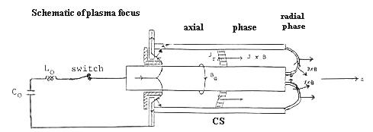

Figure II. The Rogowski coil with a sufficiently small terminating resistance to give an output proportional to current I. The large pulsed current to be measured flows through the major circumference of the coil and is completely surrounded by the minor circles of the toroidal coil.
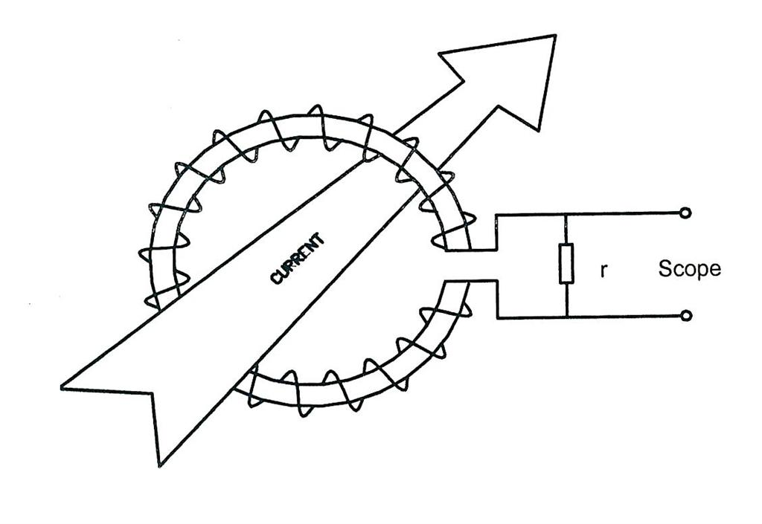

Figure III. Circuit diagram of the Rogowski coil
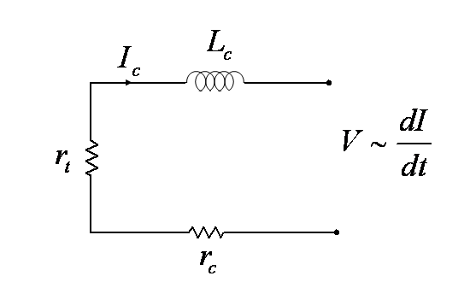

Figure IV. Typical INTI PF current waveform measured by SRC coil measurement system
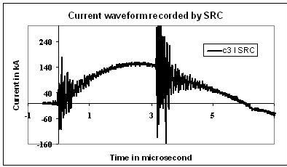

Figure V. Effect of FFT filtering at different low pass (LP) frequencies on the current waveform shown in
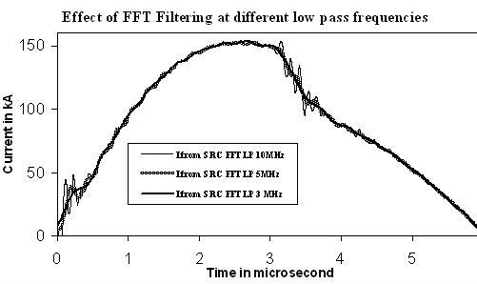

Figure VI. A typical output from the INTI PF 7-turn Idot coil. Vertical scale is dI/dt in arbitrary units
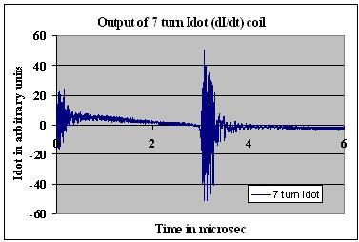

Figure VII. Comparing the current waveform integrated from the 7-turn Idot coil with the current waveform taken from the SRC and FTT filtered at low pass of 5 MHz

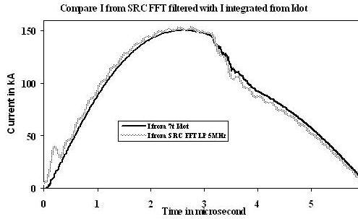

Figure VIII. Current waveform from an incorrectly designed Idot coil (100 turns) represented by a dashed line, and current waveform from a defective coil (thin line) compared to current waveform computed from the Lee Model code. The waveform computed from the code could not be made to fit either incorrect current waveform.

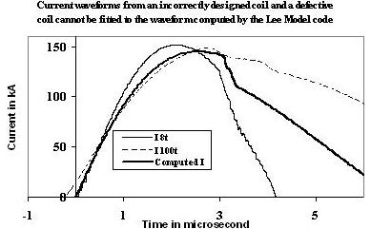

Figure IX. Fitting the measured current waveform by the Lee Model code using realistic physical parameters of: 110nH, 30 μF, 13 mΩ, 3.2 cm, 0.95 cm, 16 cm, model parameters of 0.029, 0.7, 0.29 and 0.7 at operating parameters of 12 kV, 1.75 Torr neon.
