Scaling laws for plasma focus machines from numerical experiments
S H Saw^{1,3} and S Lee^{1,2,3}

¹INTI University College, 71800 Nilai, Malaysia
²NSSE, National Institute of Education, Nanyang Technological University, Singapore 637616
³Institute for Plasma Focus Studies, 32 Oakpark Drive, Chadstone, VIC3148, Australia

Abstract
Numerical experiments carried out systematically using the Lee Model code unveil insightful and practical scaling laws for plasma focus machines. The experiments cover a range of plasma focus machines and over a range of storage energies. An essential feature and necessary first step of the numerical experiments involves the fitting of a measured current waveform to the numerical current waveform to correctly calibrate the model for the particular plasma focus machine. This crucial process provides a reliable and rigorous method to determine the ever so important pinch current. The thermodynamics and radiation properties of the resulting plasma are then reliably determined. This paper provides an overview of the recently published scaling laws for neutrons and neon SXR yield for plasma focus machines.

For neutron yield:
Y_{n} = 3.2x10¹¹ I_{pinch}^{4.5} ; Y_{n} = 1.8x10¹⁰ I_{peak}^{3.8}; I_{peak} (0.3 to 5.7), I_{pinch} (0.2 to 2.4) in MA.
Y_{n}~E₀^{2.0} at tens of kJ to Y_{n}~E₀^{0.84} at MJ level (up to 25MJ).

For neon soft x-rays:
Y_{sxr} = 8.3x10³ I_{pinch}^{3.6} ; Y_{sxr} = 6x10² I_{peak}^{3.2} ; I_{peak} (0.1 to 2.4), I_{pinch} (0.07 to1.3) in MA.
Y_{sxr}~E₀^{1.6} (kJ range) to Y_{sxr}~E₀^{0.8} (towards MJ).

- Introduction

Plasma focus machines of various energies are increasingly being studied as sources of neutrons and soft x-rays. Even a simple machine such as the UNU ICTP PFF 3 kJ machine consistently produces 10⁸ neutrons when operated in deuterium [1]. Plasma focus machines operated in neon have also been studied as intense sources of soft x-rays with potential applications [2]-[4]. Whilst many recent experiments have concentrated efforts on low energy devices[2]-[4] with a view of operating these as repetitively pulsed sources, other experiments have looked at x-ray pulses from larger plasma focus devices [5], [6] extending to the MJ regime. Numerical experiments simulating x-ray pulses from plasma focus devices are also gaining more interest in the public domain. For example, the Institute of Plasma Focus Studies [7] conducted a recent international Internet Workshop on Plasma Focus Numerical Experiments [8], at which it was demonstrated that the Lee model code [9] not only computes realistic focus pinch parameters, but also absolute values of soft x-ray yield Y_{sxr} which are consistent with those measured experimentally. A comparison was made for the case of the NX2 machine [4], showing good agreement between computed and measured Y_{sxr} as a function of P₀ [8], [10]. This gives confidence that the Lee model code gives realistic results in the computation of Y_{sxr}.

In this paper, we show the comprehensive range of numerical experiments conducted to derive scaling laws on neutron yield Y_{n} [11], [12] and neon Y_{sxr}, in terms of E₀, peak discharge current I_{peak} and peak focus pinch current I_{pinch} obtained from studies carried out over bank energies varying from 0.2 kJ to 25 MJ for optimised machine parameters and operating parameters. It is worth mentioning that the scaling laws in terms I_{pinch} and I_{peak} have also been obtained for numerical experiments using the Lee model code fitted with the actual machine parameters and operating parameters and the difference from that obtained for the optimised conditions are within the order of 0.1 in the scaling laws power factor for neutrons and no difference for neon SXR yield.

We also wish to point out that the distinction of I_{pinch} from I_{peak} is of basic importance [13]-[15]. The scaling with I_{pinch} is the more fundamental and robust one; since obviously there are situations (no pinching or poor pinching however optimized) where I_{peak} may be large but Y_{n} is zero or small; whereas the scaling with I_{pinch} is certainly more consistent with all situations. In these works the primary importance of I_{pinch} for scaling plasma focus properties including neutron yield Y_{n}, has been firmly established [11]-[15].

- The Lee Model Code

The Lee model code couples the electrical circuit with plasma focus dynamics, thermodynamics and radiation, enabling realistic simulation of all gross focus properties. The basic model, described in 1984 [16] was successfully used to assist several projects [17]-[19]. Radiation-coupled dynamics was included in the five-phase code leading to numerical experiments on radiation cooling [20]. The vital role of a finite small disturbance speed discussed by Potter in a Z-pinch situation [21] was incorporated together with real gas thermodynamics and radiation-yield terms. Before this ‘communication delay effect’ was incorporated, the model consistently over-estimated the radial speeds. This is serious from the point of view of neutron yields. A factor of two in shock speeds gives a factor of four in temperatures leading to a difference in fusion cross-sections of ~1000 at the range of temperatures we are dealing with. This version of the code assisted other research projects [22]-[27] and was web-published in 2000 [28] and 2005 [29]. Plasma self-absorption was included in 2007 [27] improving SXR yield simulation. The code has been used extensively in several machines including UNU/ICTP PFF [1], [17], [22], [23], [25]-[27], [30], [31], NX2 [24], [27], [32], NX1 [3], [32] and adapted for the Filippov-type plasma focus DENA [33]. A recent development is the inclusion of the neutron yield Y_{n} using a beam–target mechanism [11], [12], [14], [15], [34], incorporated in recent versions [9] of the code (versions later than RADPFV5.13), resulting in realistic Y_{n} scaling with I_{pinch} [11], [12]. The versatility and utility of the model is demonstrated in its clear distinction of I_{pinch} from I_{peak} [13] and the recent uncovering of a plasma focus pinch current limitation effect [14], [15]. The description, theory, code and a broad range of results of this ‘Universal Plasma Focus Laboratory Facility’ is available for download from [9].
A brief description of the code is given below. The five phases are summarised as follows:
- Axial Phase: Described by a snowplow model with an equation of motion coupled to a circuit equation. The equation of motion incorporates the axial phase model parameters: mass and current factors f_{m} and f_{c} respectively. The mass swept-up factor f_{m} accounts for not only the porosity of the current sheet but also for the inclination of the moving current sheet−shock front structure and all other unspecified effects which have effects equivalent to increasing or reducing the amount of mass in the moving structure− during the axial phase. The current factor f_{c} accounts for the fraction of current effectively flowing in the moving structure (due to all effects such as current shedding at or near the back-wall and current sheet inclination). This defines the fraction of current effectively driving the structure during the axial phase.

- Radial Inward Shock Phase: Described by four coupled equations using an elongating slug model. The first equation computes the radial inward shock speed from the driving magnetic pressure. The second equation computes the axial elongation speed of the column. The third equation computes the speed of the current sheath, also called the magnetic piston, allowing the current sheath to separate from the shock front by applying an adiabatic approximation. The fourth is the circuit equation. Thermodynamic effects due to ionization and excitation are incorporated into these equations, these effects being important for gases other than hydrogen and deuterium. Temperature and number densities are computed during this phase. A communication delay between shock front and current sheath due to the finite small disturbance speed is crucially implemented in this phase. The model parameters, radial phase mass swept-up and current factors f_{mr} and f_{cr} are incorporated in all three radial phases. The mass swept-up factor f_{mr} accounts for all mechanisms which have effects equivalent to increasing or reducing the amount of mass in the moving slug during the radial phase. The current factor f_{cr} accounts for the fraction of current effectively flowing in the moving piston forming the back of the slug (due to all effects). This defines the fraction of current effectively driving the radial slug.

- Radial Reflected Shock (RS) Phase: When the shock front hits the axis, because the focus plasma is collisional, a reflected shock develops which moves radially outwards, whilst the radial current sheath piston continues to move inwards. Four coupled equations are also used to describe this phase, these being for the reflected shock moving radially outwards, the piston moving radially inwards, the elongation of the annular column and the circuit. The same model parameters f_{mr} and f_{cr} are used as in the previous radial phase. The plasma temperature behind the RS undergoes a jump by a factor nearly two.

- Slow Compression (Quiescent) or Pinch Phase: When the out-going reflected shock hits the in-going piston the compression enters a radiative phase in which for gases such as neon, radiation emission may actually enhance the compression, where we have included energy loss/gain terms from Joule heating and radiation losses into the piston equation of motion. Three coupled equations describe this phase; these being the piston radial motion equation, the pinch column elongation equation and the circuit equation, incorporating the same model parameters as in the previous two phases. Thermodynamic effects are incorporated into this phase. The duration of this slow compression phase is set as the time of transit of small disturbances across the pinched plasma column. The computation of this phase is terminated at the end of this duration.

- Expanded Column Phase: To simulate the current trace beyond this point, we allow the column to suddenly attain the radius of the anode, and use the expanded column inductance for further integration. In this final phase the snowplow model is used, and two coupled equations are used; similar to the axial phase above. This phase is not considered important as it occurs after the focus pinch.

- Computation of Neutron yield
The neutron yield is computed using a phenomenological beam-target neutron generating mechanism described recently by Gribkov et al [34] and adapted to yield the following equation. A beam of fast deuteron ions is produced by diode action in a thin layer close to the anode, with plasma disruptions generating the necessary high voltages. The beam interacts with the hot dense plasma of the focus pinch column to produce the fusion neutrons. The beam-target yield is derived [11], [12], [14],[28] as:
Y_{b-t}= C_{n} n_{i} I_{pinch} ²z_{p} ²(ln (b/r_{p}))σ /U ^{0.5} (1)
where n_{i} is the ion density, b is the cathode radius, r_{p} is the radius of the plasma pinch with length z_{p}, σ the cross-section of the D-D fusion reaction, n- branch [35] and U, the beam energy. C_{n} is treated as a calibration constant combining various constants in the derivation process.
The D-D cross-section is sensitive to the beam energy in the range 15-150 kV; so it is necessary to use the appropriate range of beam energy to compute σ. The code computes induced voltages (due to current motion inductive effects) V_{max} of the order of only 15-50 kV. However it is known, from experiments that the ion energy responsible for the beam-target neutrons is in the range 50-150 keV [34], and for smaller lower-voltage machines the relevant energy could be lower at 30-60 keV [31]. Thus in line with experimental observations the D-D cross section σ is reasonably obtained by using U = 3V_{max}. This fit was tested by using U equal to various multiples of V_{max}. A reasonably good fit of the computed neutron yields to the measured published neutron yields at energy levels from sub-kJ to near MJ was obtained when the multiple of 3 was used; with poor agreement for most of the data points when for example a multiple of 1 or 2 or 4 or 5 was used. The model uses a value of C_{n}=2.7x10⁷ obtained by calibrating the yield [9], [13]-[14] at an experimental point of 0.5 MA.
The thermonuclear component is also computed in every case and it is found that this component is negligible when compared with the beam-target component.
- Computation of Neon SXR yield
We note that the transition from Phase 4 to Phase 5 is observed in laboratory measurements to occur in an extremely short time with plasma/current disruptions resulting in localized regions of high densities and temperatures. These localized regions are not modelled in the code, which consequently computes only an average uniform density, and an average uniform temperature which are considerably lower than measured peak density and temperature. However, because the 4 model parameters are obtained by fitting the computed total current waveform to the measured total current waveform, the model incorporates the energy and mass balances equivalent, at least in the gross sense, to all the processes which are not even specifically modelled. Hence the computed gross features such as speeds and trajectories and integrated soft x-ray yields have been extensively tested in numerical experiments for several machines and are found to be comparable with measured values.
In the code[9], neon line radiation Q_{L} is calculated as follows:
(2)
(
)
T
z
r
ZZ
n
x
dt
dQ
p
n
i
L
/
10
6
.
4
f
2
4
2
31
π
−
−
=
where for the temperatures of interest in our experiments we take the SXR yield Y_{sxr} = Q_{L}. Z_{n} is the atomic number.
Hence the SXR energy generated within the plasma pinch depends on the properties: number density n_{i}, effective charge number Z, pinch radius r_{p}, pinch length z_{f} and temperature T. It also depends on the pinch duration since in our code the Q_{L} is obtained by integrating over the pinch duration.
This generated energy is then reduced by the plasma self-absorption which depends primarily on density and temperature; the reduced quantity of energy is then emitted as the SXR yield. These effects are included in the modelling by computing volumetric plasma self-absorption factor A derived from the photonic excitation number M which is a function of Z_{n}, n_{i}, Z and T. However, in our range of operation, the numerical experiments show that the self absorption is not significant. It was first pointed out by Liu Mahe [23] that a temperature around 300 eV is optimum for SXR production. Shan Bing’s subsequent work [24] and our experience through numerical experiments suggest that around 2x10⁶ K (below 200 eV) or even a little lower could be better. Hence unlike the case of neutron scaling, for SXR scaling there is an optimum small range of temperatures (T windows) to operate.

- Numerical Experiments
The Lee code is configured to work as any plasma focus by inputting the bank parameters, L₀, C₀ and stray circuit resistance r₀; the tube parameters b, a and z₀ and operational parameters V₀ and P₀ and the fill gas. The standard practice is to fit the computed total current waveform to an experimentally measured total current waveform[11], [13]-[15], [28]-[29] using the four model parameters representing the mass swept-up factor f_{m}, the plasma current factor f_{c} for the axial phase and factors f_{mr} and f_{cr} for the radial phases.
From experience it is known that the current trace of the focus is one of the best indicators of gross performance. The axial and radial phase dynamics and the crucial energy transfer into the focus pinch are among the important information that is quickly apparent from the current trace.
The exact time profile of the total current trace is governed by the bank parameters, by the focus tube geometry and the operational parameters. It also depends on the fraction of mass swept-up and the fraction of sheath current and the variation of these fractions through the axial and radial phases. These parameters determine the axial and radial dynamics, specifically the axial and radial speeds which in turn affect the profile and magnitudes of the discharge current. The detailed profile of the discharge current during the pinch phase also reflects the Joule heating and radiative yields. At the end of the pinch phase the total current profile also reflects the sudden transition of the current flow from a constricted pinch to a large column flow. Thus the discharge current powers all dynamic, electrodynamic, thermodynamic and radiation processes in the various phases of the plasma focus. Conversely all the dynamic, electrodynamic, thermodynamic and radiation processes in the various phases of the plasma focus affect the discharge current. It is then no exaggeration to say that the discharge current waveform contains information on all the dynamic, electrodynamic, thermodynamic and radiation processes that occur in the various phases of the plasma focus. This explains the importance attached to matching the computed current trace to the measured current trace in the procedure adopted by the Lee model code.
- Scaling laws for neutrons from numerical experiments over a range of energies from 10kJ to 25 MJ
We apply the Lee model code to the MJ machine PF1000 over a range of C₀ to study the neutrons emitted by PF1000-like bank energies from 10kJ to 25 MJ.
A measured current trace of the PF1000 with C₀ = 1332 μF, operated at 27 kV, 3.5 torr deuterium, has been published [34], with cathode/anode radii b = 16 cm, a = 11.55 cm and anode length z₀ = 60 cm. In the numerical experiments we fitted external (or static) inductance L₀= 33.5 nH and stray resistance r₀ = 6.1 mΩ (damping factor RESF= r₀/(L₀/C₀)^{0.5} = 1.22). The fitted model parameters are: f_{m} = 0.13, f_{c} = 0.7, f_{mr} = 0.35 and f_{cr}= 0.65. The computed current trace [11], [15] agrees very well with the measured trace through all the phases, axial and radial, right down to the bottom of the current dip indicating the end of the pinch phase as shown in Fig.1.
This agreement confirms the model parameters for the PF1000. Once the model parameters have been fitted to a machine for a given gas, these model parameters may be used with some degree of confidence when operating parameters such as the voltage are varied [9]. With no measured current waveforms available for the higher megajoule numerical experiments, it is reasonable to keep the model parameters that we have got from the PF1000 fitting.
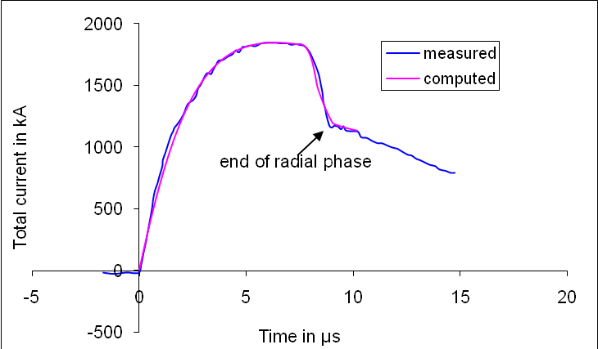
Fig 1. Current fitting computed current to measured current traces to obtain fitted parameters f_{m} = 0.13, f_{c} = 0.7, f_{mr} = 0.35 and f_{cr}= 0.65.
The optimum pressure for this series of numerical experiments is 10 torr and the ratio c=b/a is retained at 1.39. For each C₀, anode length z₀ is varied to find the optimum. For each z₀, anode radius a₀ is varied so that the end axial speed is 10 cm/µs. The numerical experiments were carried out for C₀ ranging from 14 µF to 39960 µF corresponding to energies from 8.5 kJ to 24 MJ [12].
For this series of experiments we find that the Y_{n} scaling changes from Y_{n}~E₀^{2.0} at tens of kJ to Y_{n}~E₀^{0.84} at the highest energies (up to 25MJ) investigated in this series. This is shown in Fig 2.
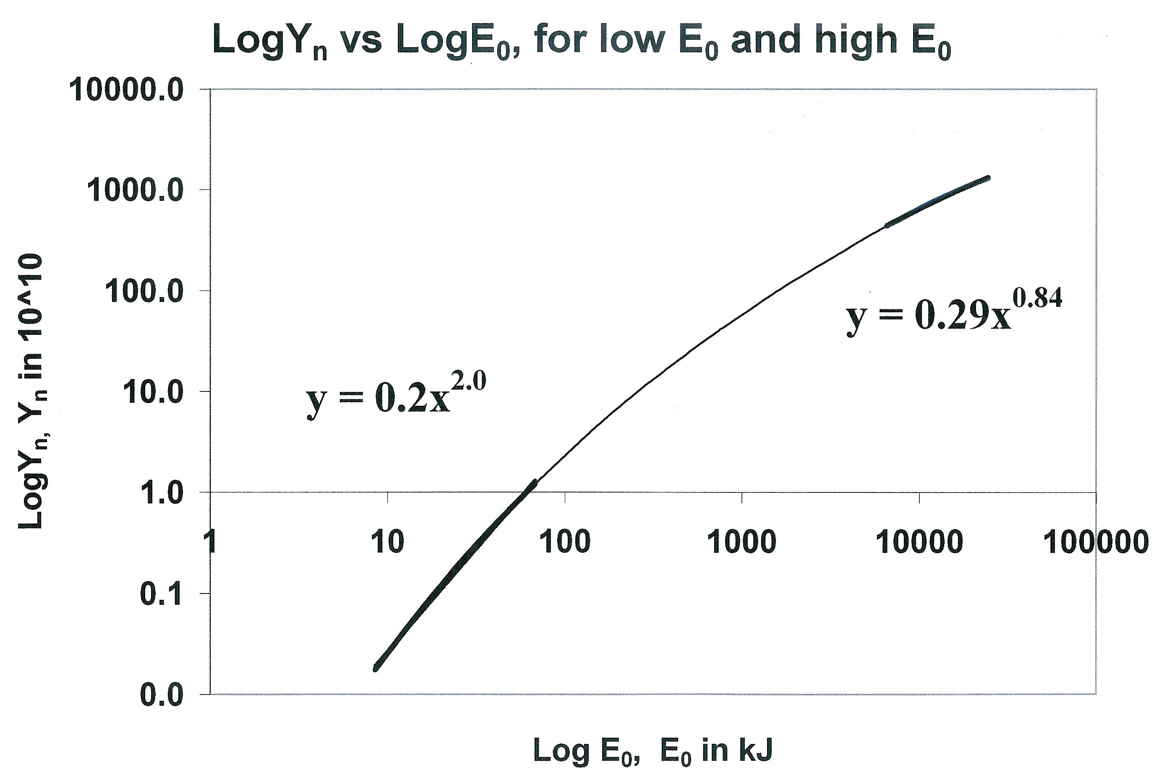
Fig 2. Y_{n} plotted as a function of E₀ in log-log scale, showing Y_{n} scaling changes from Y_{n}~E₀^{2.0} at tens of kJ to Y_{n}~E₀^{0.84} at the highest energies (up to 25MJ).

The scaling of Y_{n} with I_{peak} and I_{pinch} over the whole range of energies investigated up to 25 MJ (Fig. 3) is as follows:
Y_{n} = 3.2x10¹¹ I_{pinch}^{4.5} and
Y_{n} = 1.8x10¹⁰ I_{peak}^{3.8}
where I_{peak} ranges from 0.3 MA to 5.7 MA and I_{pinch} ranges from 0.2 MA to 2.4 MA.
Fig. 3. Log(Y_{n}) scaling with Log(I_{peak}) and Log(I_{pinch}), for the range of energies investigated, up to 25 MJ
This compares to an earlier study carried out on several machines with published current traces and Y_{n} yield measurements, operating conditions and machine parameters including the PF400, UNU/ICTP PFF, the NX2 and Poseidon providing a slightly higher scaling laws: Y_{n} ~ I_{pinch}^{4.7} and Y_{n} ~ I_{peak}^{3.9}. The slightly higher value of the scaling is because those machines fitted are of mixed 'c' mixed bank parameters, mixed model parameters and currents generally below 1MA and voltages generally below the 35 kV [11].
- Scaling laws for neon SXR from numerical experiments over a range of energies from 0.2 kJ to 1 MJ
We next use the Lee model code to carry out a series of numerical experiments over the energy range 0.2 kJ to 1 MJ [35]. In this case we apply it to a proposed modern fast plasma focus machine with optimised values for c the ratio of the outer to inner electrode radius and L₀ obtained from our numerical experiments.
The following parameters are kept constant : (i) the ratio c=b/a (kept at 1.5, which is practically optimum according to our preliminary numerical trials; (ii) the operating voltage V₀ (kept at 20 kV); (iii) static inductance L₀ (kept at 30 nH, which is already low enough to reach the I_{pinch} limitation regime [13], [14] over most of the range of E₀ we are covering) and; (iv) the ratio of stray resistance to surge impedance RESF (kept at 0.1, representing a higher performance modern capacitor bank). The model parameters [8]-[14] f_{m}, f_{c}, f_{mr}, f_{cr} are also kept at fixed values 0.06, 0.7, 0.16 and 0.7. We choose the model parameters are they represent the average values from the range of machines that we have studied.
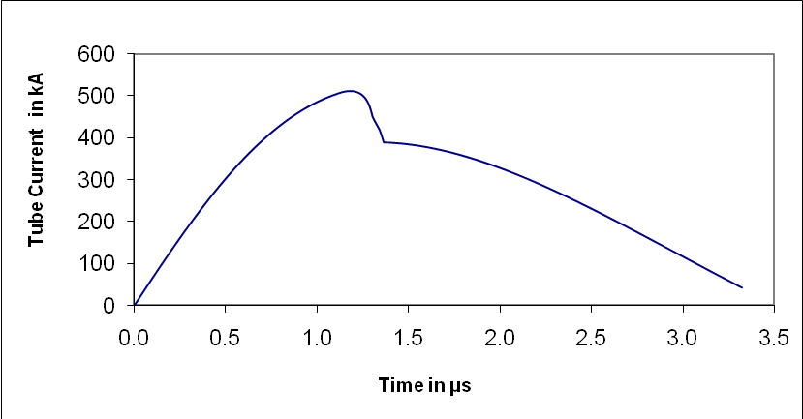
Fig 4. Computed total curent versus time for L ₀= 30 nH and V₀ = 20 kV, C₀ = 30 uF, RESF = 0.1, c = 1.5 and model parameters f_{m}, f_{c}, f_{mr}, f_{cr} are fixed at 0.06, 0.7, 0.16 and 0.7 for optimised a = 2.285cm and z₀ = 5.2 cm.
The storage energy E₀ is varied by changing the capacitance C₀. Parameters that are varied are operating pressure P₀, anode length z₀ and anode radius a. Parametric variation at each E₀ follows the order; P₀, z₀ and a until all realistic combinations of P₀, z₀ and a are investigated. At each E₀, the optimum combination of P₀, z₀ and a is found that produces the biggest Y_{sxr}. In other words at each E₀, a P₀ is fixed, a z₀ is chosen and a is varied until the largest Y_{sxr} is found. Then keeping the same values of E₀ and P₀, another z₀ is chosen and a is varied until the largest Y_{sxr} is found. This procedure is repeated until for that E₀ and P₀, the optimum combination of z₀ and a is found. Then keeping the same value of E₀, another P₀ is selected. The procedure for parametric variation of z₀ and a as described above is then carried out for this E₀ and new P₀ until the optimum combination of z₀ and a is found. This procedure is repeated until for a fixed value of E₀, the optimum combination of P₀, z₀ and a is found.
The procedure is then repeated with a new value of E₀. In this manner after systematically carrying out some 2000 runs, the optimized runs for various energies are tabulated in Table 1. From the data of Table 1, we plot Y_{sxr} against E₀ as shown in Fig 5.
Table 1. Optimised configuration found for each E₀. Optimisation carried out with RESF = 0.1, c = 1.5, L₀ = 30 nH and V₀ = 20 kV and model parameters f_{m}, f_{c}, f_{mr}, f_{cr} are fixed at 0.06, 0.7, 0.16 and 0.7 respectively. The v_{a}, v_{s} and v_{p} are the peak axial, radial shock and radial piston speeds respectively.
E₀  (kJ) | C₀  (μF) | a  (cm) | z₀  (cm) | P₀  (Torr) | I_{peak}  (kA) | I_{pinch}  (kA) | v_{a}  (cm/μs) | v_{s}  (cm/μs) | v_{p}  (cm/μs) | Y_{sxr}  (J)
0.2 | 1 | 0.58 | 0.5 | 4.0 | 100 | 68 | 5.6 | 22.5 | 14.9 | 0.44
1 | 5 | 1.18 | 1.5 | 4.0 | 224 | 143 | 6.6 | 23.3 | 15.1 | 7.5
2 | 10 | 1.52 | 2.1 | 4.0 | 300 | 186 | 6.8 | 23.6 | 15.2 | 20
6 | 30 | 2.29 | 5.2 | 4.2 | 512 | 294 | 8.1 | 24.5 | 15.6 | 98
10 | 50 | 2.79 | 7.5 | 4.0 | 642 | 356 | 8.7 | 24.6 | 15.7 | 190
20 | 100 | 3.50 | 13 | 4.0 | 861 | 456 | 9.6 | 24.6 | 16.0 | 470
40 | 200 | 4.55 | 20 | 3.5 | 1109 | 565 | 10.3 | 24.7 | 16.2 | 1000
100 | 500 | 6.21 | 42 | 3.0 | 1477 | 727 | 11.2 | 24.8 | 16.4 | 2700
200 | 1000 | 7.42 | 63 | 3.0 | 1778 | 876 | 11.4 | 24.8 | 16.5 | 5300
400 | 2000 | 8.70 | 98 | 3.0 | 2079 | 1036 | 11.4 | 24.9 | 16.5 | 9400
500 | 2500 | 9.10 | 105 | 2.9 | 2157 | 1086 | 11.5 | 25.1 | 16.7 | 11000
1000 | 5000 | 10.2 | 160 | 3.0 | 2428 | 1261 | 11.4 | 25.2 | 16.7 | 18000

We then plot Y_{sxr} against I_{peak} and I_{pinch} and obtain SXR yield scales as Y_{sxr}~I_{pinch}^{3.6} and Y_{sxr}~I_{peak}^{3.2}. The I_{pinch} scaling has less scatter than the I_{peak} scaling. We next subject the scaling to further test when the fixed parameters RESF, c, L₀ and V₀ and model parameters f_{m}, f_{c}, f_{mr}, f_{cr} are varied. We add in the results of some numerical experiments using the parameters of several existing plasma focus devices including the UNU/ICTP PFF (RESF = 0.2, c = 3.4, L₀ = 110 nH and V₀ = 14 kV with fitted model parameters f_{m} = 0.05, f_{c} = 0.7, f_{mr} = 0.2, f_{cr} = 0.8)[7]-[9], [23], the NX2 (RESF = 0.1, c = 2.2, L₀ = 20 nH and V₀ = 11 kV with fitted model parameters f_{m} = 0.10, f_{c} = 0.7, f_{mr} = 0.12, f_{cr} = 0.68)[7]-[10], [24] and PF1000 (RESF = 0.1, c = 1.39, L₀ = 33 nH and V₀ = 27 kV with fitted model parameters f_{m} = 0.1, f_{c} = 0.7, f_{mr} = 0.15, f_{cr} = 0.7) [7]-[9], [14]. These new data points (white data points in Fig. 6) contain wide ranges of c, V₀, L₀ and model parameters. The resulting Y_{sxr} versus I_{pinch} log-log curve remains a straight line, with the scaling index 3.6 unchanged and with no more scatter than before. However the resulting Y_{sxr} versus I_{peak} curve now exhibits considerably larger scatter and the scaling index has changed.
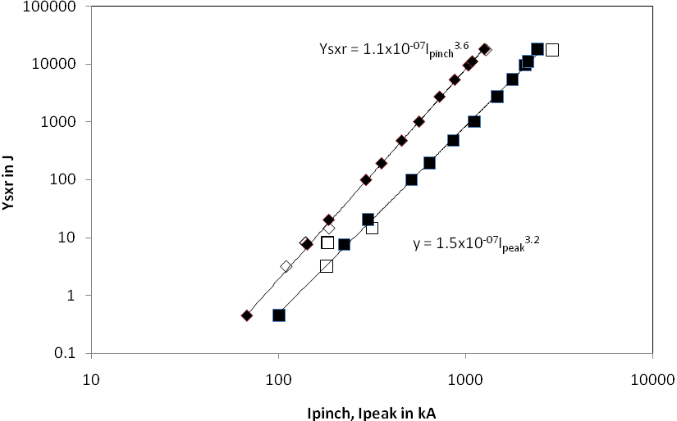
Fig 6. Y_{sxr} is plotted as a function of I_{pinch} and I_{peak}. The parameters kept constant for the black data points are: RESF = 0.1, c = 1.5, L₀ = 30nH and V₀ = 20 kV and model parameters f_{m}, f_{c}, f_{mr}, f_{cr} at 0.06, 0.7, 0.16 and 0.7 respectively. The white data points are for specific machines which have different values for the parameters c, L₀ and V₀.
We would like to highlight that the consistent behaviour of I_{pinch} in maintaining the scaling of Y_{sxr} ~ I_{pinch}^{3.6} with less scatter than the Y_{sxr}~I_{peak}^{3.2} scaling particularly when mixed-parameters cases are included, strongly support the conclusion that I_{pinch} scaling is the more universal and robust one. Similarly conclusions on the importance of I_{pinch} in plasma focus performance and scaling laws have been reported [11]-[15].
It may also be worthy of note that our comprehensively surveyed numerical experiments for Mather configurations in the range of energies 0.2 kJ to 1 MJ produce an I_{pinch} scaling rule for Y_{sxr} not compatible with Gates’ rule [37]. However it is remarkable that our I_{pinch} scaling index of 3.6, obtained through a set of comprehensive numerical experiments over a range of 0.2 kJ to 1 MJ, on Mather-type devices is within the range of 3.5-4 postulated on the basis of sparse experimental data, (basically just two machines one at 5 kJ and the other at 0.9 MJ), by Filippov [6], for Filippov configurations in the range of energies 5 kJ to 1 MJ.
It must be pointed out that the results represent scaling for comparison with baseline plasma focus devices that have been optimized in terms of electrode dimensions. It must also be emphasized that the scaling with I_{pinch} works well even when there are some variations in the actual device from L₀ = 30 nH, V₀ = 20 kV and c = 1.5. However there may be many other parameters which can change which could lead to a further enhancement of x-ray yield.

Conclusion

Numerical experiments carried out using the universal plasma focus laboratory facility based on the Lee model code gives reliable scaling laws for neutrons production and neon SXR yields for plasma focus machines. The scaling laws obtained:

For neutron yield:
Y_{n} = 3.2x10¹¹ I_{pinch}^{4.5} ; Y_{n} = 1.8x10¹⁰ I_{peak}^{3.8}; I_{peak} (0.3 to 5.7), I_{pinch} (0.2 to 2.4) in MA.
Y_{n}~E₀^{2.0} at tens of kJ to Y_{n}~E₀^{0.84} at MJ level (up to 25MJ).

For neon soft x-rays:
Y_{sxr} = 8.3x10³ I_{pinch}^{3.6} ; Y_{sxr} = 6x10² I_{peak}^{3.2} ; I_{peak} (0.1 to 2.4), I_{pinch} (0.07 to1.3) in MA.
Y_{sxr}~E₀^{1.6} (kJ range) to Y_{sxr}~E₀^{0.8} (towards MJ).

These laws provide useful references and facilitate the understanding of present plasma focus machines. More importantly, these scaling laws are also useful for design considerations of new plasma focus machines particularly if they are intended to operate as optimized neutron or neon SXR sources.

Acknowledgement

The authors acknowledge the contributions of Paul Lee and Rajdeep Singh Rawat to various parts of this paper.

References
- S Lee, “Twelve Years of UNU/ICTP PFF—A Review,” IC/ 98/ 231 Abdus Salam ICTP, Miramare, Trieste; 1998, pp.5-34. ICTP Open Access Archive http://eprints.ictp.it/31/.
- Kato Y and Be S H 1986 Appl. Phys. Lett. 48 686
- E P Bogolyubov, V D Bochkov, V A Veretennikov, L T Vekhoreva, V A Gribkov, A V Dubrovskii, Yu P Ivanov, A I Isakov, O N Krokhin, P Lee, S Lee, V Ya Nikulin, A Serban, P V Silin, X Feng and G X Zhang, “A powerful soft x-ray source for x-ray lithography based on plasma focusing” 1998 Phys. Scripta., vol. 57, 1998, pp. 488-494.
- Lee S, Lee P, Zhang G, Feng X, Gribkov V A, Mahe L, Serban A, and Wong T K S 1998 IEEE Trans. Plasma Sci. 26 1119
- Filippov N V, Filippova T I, Karakin M A, Krauz V I, Tykshaev V P, Vinogradov V P, Bakulin Y P, Timofeev V V, Zinchenko V F, Brzosko J R, Brzosko J S, IEEE Trans Plasma Sci. 24, 1215 – 1223, 1996
- Filippov N V, Filippova T I, Khutoretskaia I V, Mialton V V and Vinogradov V P,” Megajoule scale plasma focus as efficient X-ray source,” Physics Letters A Vol 211, Issue 3, 168-171, 1996
- Institute for Plasma Focus Studies http://www.plasmafocus.net
- Internet Workshop on Plasma Focus Numerical Experiments (IPFS-IBC1) 14 April-19 May 2008
http://www.plasmafocus.net/IPFS/Papers/IWPCAkeynote2ResultsofInternet-basedWorkshop.doc
- Lee S Radiative Dense Plasma Focus Computation Package: RADPF http://www.intimal.edu.my/school/fas/UFLF/File1RADPF.htm http://www.plasmafocus.net/IPFS/modelpackage/File1RADPF.htm
- Lee S, Rawat R S, Lee P and Saw S H. “Soft x-ray yield from NX2 plasma focus- correlation with plasma pinch parameters” (to be published)
- S Lee and S H Saw, “Neutron scaling laws from numerical experiments,” J Fusion Energy 27, 2008, pp. 292-295.
- S Lee, “Current and neutron scaling for megajoule plasma focus machine,” Plasma Phys. Control. Fusion 50, 2008, 105005, (14pp).
- S Lee, S H Saw, P C K Lee, R S Rawat and H Schmidt, “Computing plasma focus pinch current from total current measurement,” Appl. Phys. Lett. 92 , 2008, 111501.
- S Lee and S H Saw, “Pinch current limitation effect in plasma focus,” Appl. Phys. Lett. 92, 2008, 021503.
- S Lee, P Lee, S H Saw and R S Rawat, “Numerical experiments on plasma focus pinch current limitation,” Plasma Phys. Control. Fusion 50, 2008, 065012 (8pp).
- S Lee, “Plasma focus model yielding trajectory and structure” in Radiations in Plasmas, ed B McNamara (Singapore: World Scientific Publishing Co, ISBN 9971-966-37-9) vol. II, 1984, pp. 978–987
- S Lee S et al, “A simple facility for the teaching of plasma dynamics and plasma nuclear fusion,” Am. J. Phys. 56, 1988, pp. 62-68.
- T Y Tou, S Lee and K H Kwek, “Non perturbing plasma focus measurements in the run-down phase,” IEEE Trans. Plasma Sci. 17, 1989, pp. 311-315.
- S Lee, “A sequential plasma focus,” IEEE Trans. Plasma Sci., vol. 19, no. 12, 1991, pp. 912-919.
- Jalil bin Ali, “Development and Studies of a small Plasma Focus,” PhD thesis, Universiti Teknologi Malaysia, Malaysia, 1990.
- D E Potter, “The formation of high density z-pinches,” Nucl. Fus., vol. 18, pp. 813-823, 1978.
- S Lee and A Serban A, “Dimensions and lifetime of the plasma focus pinch,” IEEE Trans. Plasma Sci., vol. 24, no.3, 1996, pp. 1101-1105.
- Liu Mahe, “Soft X-rays from compact plasma focus,” PhD thesis, NIE, Nanyang Technological University, Singapore, 2006. ICTP Open Access Archive: http://eprints.ictp.it/327/.
- S Bing, “Plasma dynamics and x-ray emission of the plasma focus,” PhD Thesis, NIE, Nanyang Technological University, Singapore, 2000. ICTP Open Access Archive: http://eprints.ictp.it/99/.
- A Serban and S Lee, “Experiments on speed-enhanced neutron yield from a small plasma focus,” J Plasma Physics, vol. 60 part 1, 1998, pp. 3-15.
- M H Liu, X P Feng, S V Springham and S Lee “Soft x-ray measurement in a small plasma focus operated in neon,” IEEE Trans. Plasma Sci. 26, 1998, pp. 135–140.
- D Wong, P Lee, T Zhang, A Patran, T L Tan, R S Rawat and S Lee, “An improved radiative plasma focus model calibrated for neon-filled NX2 using a tapered anode,” Plasma Sources Sci. Technol. 16, 2007, pp. 116-123.
- S Lee. (2000–2007). http://ckplee.myplace.nie.edu.sg/plasmaphysics/.
- S Lee. (2005). ICTP Open Access Archive: http://eprints.ictp.it/85/.
- M A Mohammadi, S Sobhanian, C S Wong, S Lee, P Lee and R S Rawat , “The effect of anode shape on neon soft x-ray emissions and current sheath configuration in plasma focus device,” J. Phys. D: Appl.Phys. 42, 2009, 045203 (10pp).
- S V Springham, S Lee and M S Rafique, “Correlated deuteron energy spectra and neutron yield for a 3 kJ plasma focus,” Plasma Phys. Control. Fusion, vol. 42, 2000, pp. 1023-1032.
- S Lee, P Lee, G Zhang, X Feng, V A Gribkov, M Liu, A Serban and T Wong “High rep rate high performance plasma focus as a powerful radiation source” IEEE Trans. Plasma Sci., vol. 26, no. 4, 1998, pp. 1119-1126.
- V Siahpoush, M A Tafreshi, S Sobhanian and S Khorram, “Adaptation of Sing Lee’s model to the Filippov type plasma focus geometry,” Plasma Phys. Control. Fusion 47, 2005, pp. 1065-1072.
- V A Gribkov, A Banaszak, B Bienkowska, A V Dubrovsky, I Ivanova-Stanik, L Jakubowski, L Karpinski, R A Miklaszewski, M Paduch, M J Sadowski, M Scholz, A Szydlowski and K Tomaszewski, “Plasma dynamics in the PF-1000 device under full-scale energy storage: II. Fast electron and ion characteristics versus neutron emission parameters and gun optimization perspectives,” J. Phys. D: Appl. Phys. 40, 2007, pp. 3592-3607.
- Huba J D 2006 Plasma Formulary page 44
- S Lee, S H Saw, P Lee and R S Rawat, “Numerical experiments on plasma focus neon soft x-ray scaling”, (to be published).
- D C Gates 1978 Proceedings of the IInd Int Conference on Energy Storage, Compression and Switching, Venice, 2, 3239 (Plenum Press, New York, 1983).

