Fusion Energy and the Plasma Focus
Sing Lee
(Proceedings: pp 9-18)
Institute for Plasma Focus Studies, 32, Oakpark Drive, Chadstone VIC3148, Australia
INTI University College, 71800 Nilai, Malaysia
Nanyang Technological University, National Institute of Education, Singapore 637616
e-mail: leesing@optusnet.com.au
Abstract
[1] An introduction is given to plasmas and fusion energy. A brief look into the past and future of Tokamak development is taken. It appears inevitable that fusion reactors will provide one of the solutions to civilization’s need for increasing energy resources; although the technological scale of presently envisaged nuclear reactors makes the adoption of the technology cumbersome to manage.
[2] Alternative simpler schemes have been suggested. One of the most promising is based on pulsed high density compressions by large currents pinch effects. Among these is the plasma focus, a device which even in a table-top form produces significant radiation emissions including nuclear fusion neutrons, from the extremely hot compressed plasma. Early hopes were based on experimental results that predicted output fusion energy scales as the square of input energy, predicting breakeven at tens of megajoules (MJ), a much smaller scale than Tokamak installations. These hopes were quickly dimmed as neutron saturation effects were observed at a relatively low MJ level. Recently, numerical experiments have shown that simple circuit effects, overlooked in earlier intense scrutiny of complex non-linear effects, lead to a current saturation tendency, which is the primary factor for the neutron saturation. With the cause identified, further numerical experiments are expected to suggest a simple solution to add current, thus overcoming the saturation. This paper acts as the platform to launch the idea of beyond-saturation plasma focus machines, which is expected to enhance the prospects of plasma focus fusion energy research.

Keywords: Fusion Energy, Tokamak, Plasma Focus

1. Introduction

Nuclear fusion is the process that powers the stars. The study of plasma physics has led to technological developments which point to the possibility of the use of the fusion process to develop a new, clean and limitless energy source. At the forefront of the efforts to harness this process are Tokamak machines. Technical requirements to harness nuclear fusion include high temperatures, sufficient gas fuel densities and containment times which appear to be attainable in the next generation of Tokamaks. Other programmes to develop nuclear fusion reactors involve inertial methods, including laser implosions and plasma pinch (fast compression) devices such as the plasma focus.
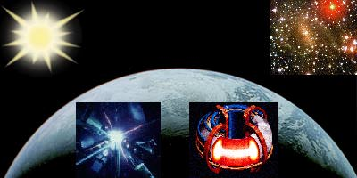
Figure1. Natural fusion reactors and experimental fusion reactors on earth
(credits: Figs 1 -11 are taken from some websites in the reference list [1-6])

Invited paper presented at the Nuclear & Renewable Energy Sources Conference 28-29 September 2009, Ankara Turkey

1.1. Plasma and plasma characteristics

Plasmas form the fourth state of matter, the other three states being solid, liquid and gases. When matter is heated to very high temperatures, some of the atoms in the matter become ionized when electrons are ejected from the atoms. When sufficient ionization is attained, the matter is in an electrically conducting gaseous state which is known as the plasma state. A plasma interacts with electric and magnetic fields. The electrons and ions in a plasma may be controlled by electric and magnetic fields. A plasma has higher energy density (per unit mass) than matter in the other three states. A constituent particle in a gas at room temperature may have several hundredths of eV (electron-volt) of energy whilst a plasma, even a ‘cold’ plasma may have energies of several eV’s (in this context: 1 eV=11,400K). A ‘hot’ plasma may have temperatures exceeding keV’s. More than 99% of matter in the universe, including the stars, exists in the plasma state.

1.2. Applications of plasmas

Plasmas have advantageous properties including high energy densities and ability to be precisely controlled by electric and magnetic fields. These properties lead to many applications [7] including surface processing, cleaning, etching, deposit of advanced materials including diamond-like and harder-than-diamond materials, materials related to nanotechnology, environmental applications such as waste disposal, high-temperature chemistry, MHD converters, thrusters, radiation sources for microelectronics lithography and micromachining, medical applications such as diagnostics, cleaning instrumentation and light sources for spectroscopy. The most important application is nuclear fusion energy.

2. Nuclear Fusion Energy

Plasma nuclear fusion promises a new limitless source of energy [1-6], essential for the continuing progress of human civilization. Mankind now stands at a dividing point in human history; 200 years ago the earth was under-populated (less than 1 billion population consuming little energy per head) with abundant resources of energy; 100 years from now, the earth will be overcrowded (25 billion population with voracious hunger for energy (assuming population doubling time of 45 years or 1.6% per year), with little energy resources left. Rate of growth will slow down amidst intensifying energy-caused conflicts unless a new large-scale source is found.

Plasma nuclear fusion is based on the following nuclear reaction:

₁H² + ₁H³ ₂H⁴ + ₀n¹

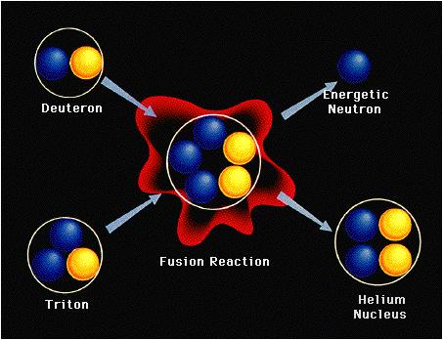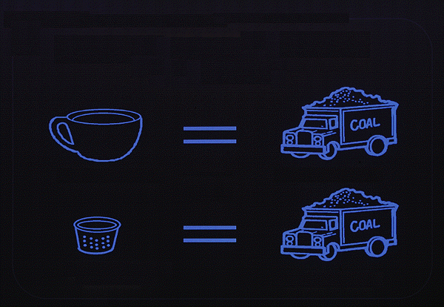
Fig 2. Deuterium-Tritium fusion Fig 3. 1 thimble of heavy water extracted from 50 cups of water undergoing nuclear fusion produces
energy equivalent to a truck of coal

The fusing of a deuteron (deuterium nucleus) with a triton (tritium nucleus), see Fig 2, to form a helium nucleus with the liberation of a neutron which carries with it the excess energy of the reaction, this excess energy coming from mass-energy conversion, since the reactons (deuteron nucleus and the tritium nucleus) have more mass than the reaction products (the helium nucleus and the neutron); a clear demonstration of Einstein’s E=mc². In the stars fusion reactions are responsible for the continuing shining of the universe. On earth the power of nuclear fusion has been demonstrated by the hydrogen bomb.

The plan of fusion scientists is to harness this same power in a controlled fashion in nuclear fusion reactors. The fuel for such reactors is practically limitless. 1 part in 6000 of sea water is heavy water (D₂O). This heavy water will act as the basic fuel for the nuclear fusion reactors and will last the most voracious usage of mankind for millions of years.

3. Conditions required for nuclear reactors

Thermalised. plasmas need to be at a high enough temperature for collisions to be able to overcome the Coulomb repulsive barrier. The ideal ignition temperature for D-T fusion is 4 keV. The other requirements are a high enough density contained for a sufficient period of time. Technological targets are set at: Temperature >10 keV (100 million K) and a density-containment time product nt>10²¹m⁻³-sec [6]. Attempts to fulfill the nt criterion appear to have settled down broadly into two approaches:

n=10²⁰ m⁻³, with confinement time t=10 second (low density, long lived plasmas, contained by magnetic fields) and
n=10³¹ m⁻³, with confinement time t=10⁻¹⁰ second (super-high density, inertially compressed pulsed plasmas, with confinement time provided by inertia).

The nt criterion together with the requirement for a high enough ignition temperature give a combined fusion product of: ntT>10²²m⁻³-sec-keV.

On the the other hand, both the requirements of high temperature and confinement in stars are provided by gravitational forces.

4. Tokamak

A Tokamak[1-6] may be described as a doughnut shaped plasma vessel in which electric currents are used for heating the plasma and magnetic fields are used to contain the plasma away from the walls. The magnetic fields need special configurations for stability over the period of containment. A schematic is shown in Fig. 4 with a cut-away section showing the plasma in the vessel. The transformer core and the field coils necessary to confine and position the plasma are shown schematically in the next Fig 5.

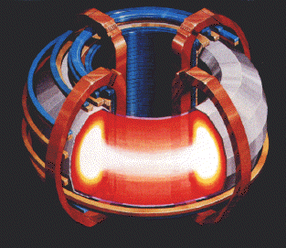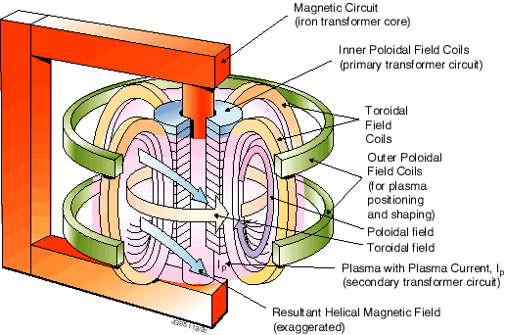
Figure 4. Tokamak vessel Figure 5. Magnetic fields for confining Tokamak Plasmas

The Joint European Torus (JET) sited at Culham, UK, is the world’s largest nuclear fusion research facility [3]. Its structure and a worker inside the toroidal vessel are shown in the next figures 6 & 7.

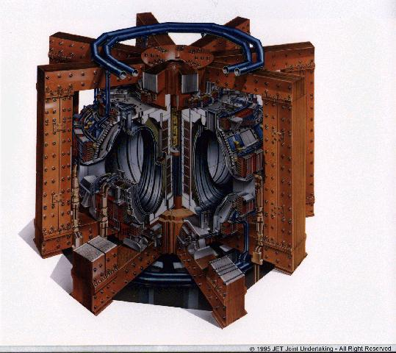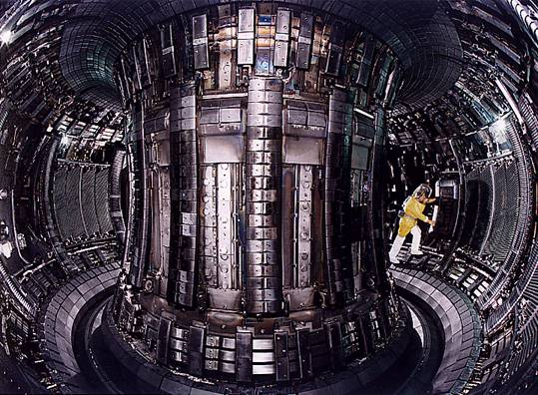
Figure 6. Struture of JET Figure 7. A worker inside the JET chamber

Progress in Tokamak research is depicted in the Fig.8, which shows that the fusion product ntT has increased 10 million times in the 51 years of Tokamak research since 1958 [6]. The required fusion temperature of >10 keV has been achieved in several Tokamaks including JET (EU), JT-60 (Japan), TFTR (US) and DIII D (US). Fusion confinement (ntT=10²²m⁻³-sec-keV for Q=1 breakeven; here Q is the ratio of output fusion energy/input energy ) is only one step away. Notably JET has already achieved Q=0.6 before year 2000.
Figure 8. Illustrating fusion progress in 51 years. Break-even is only 1 step away

Moreover from all the experiments, cutting through all the difficulties in plasma physics and engineering technology, the energy confinement time is known to scale as some functions of plasma current I_{p}. Major radius R, minor radius ‘a’ and toroidal magnetic field B. The scaling law may be expressed generally as
t~ I_{p}^{α} R^{β}a^{γ} B^{λ} with the indices all positive. To achieve a sufficiently high ntT the scaling indicates increase in I_{p}, R, a and B.
4.1 International Thermonuclear Experimental Reactor- ITER and beyond

In 1985 at the Geneva Superpower Summit, Reagan (USA) and Gorbachev (Soviet Union) agreed on a project [4,6] to develop a new, cleaner, sustainable source of energy-fusion energy. ITER was born. The initial signatories: former Soviet Union, USA, European union (via EURATOM) and Japan were joined by P R China and Republic of Korea in 2003 and India in 2005. The ITER Agreement was signed in November 2006. ITER construction has started in Cadarache, France with first plasma planned for 2018 and D-T experiments for 2022 and beyond.
Figure 9. The structure of ITER, and the site at Cadarache in France

ITER aims to demonstrate that it is possible to produce commercial energy from fusion with a scientific goal of Q> 10; ie to deliver 10 times the power it consumes; e.g. using 50 MW of input power to start and sustain the plasma, ITER will produce 500 MW of power from nuclear fusion over the cycle of the experiment.

Beyond ITER will be DEMO (early 2030’s). This will be a demonstration fusion power plant which will feed power into electricity grid as early as 2040.

More advanced Tokamak designs include FIRE (Fusion Ignition Research Experiment) a design more compact than JET yet with a design Q=10 [2,6]. A 1 GW Tokamak ARIES has already been designed. 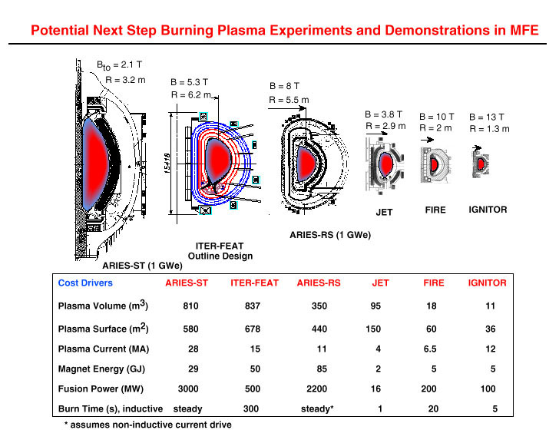
Figure 10. Comparing plasma cross-sections of planned machines with JET
Some comparative data showing plasma cross-sections is shown in Fig 10, showing the technological advantages of the more advanced yet compact designs.

5. Inertial confinement

The other approach is to use pulsed super high density [8]. The super high density may be achieved by beaming powerful pulsed lasers from all directions onto D-T pellets (typically 0.1 mm radius). The radiation pressure exerted on the surface of the pellet together with the blow-off of hot surface material cause compression of the pellet to super dense conditions which may be 1000 times the density of water. Under these hot and dense conditions, the fuel fusion-ignites. The thermonuclear fusion spreads rapidly through the super-compressed fuel. This is depicted in Fig. 11. The whole process takes place in the sub nanosecond range.



Figure. 11. Radiation induced super dense implosions leading to fusion burn

6. Pinches and the plasma focus

There is a view that whereas Tokamaks and laser implosions will likely be the devices to succeed in the efforts to harness nuclear fusion, these are huge programmes which will take extraordinary amounts of combined international resources and cooperation on a scale never before attempted.. Ongoing research on other devices such as pinches has shown that these are able to produce nuclear fusion even in devices of much smaller scales [9].

An electrical discharge between two electrodes produces an azimuthal magnetic field which interacts with the column of current, giving rise to a self-compression force which tends to constrict (or pinch) the column. In order to ‘pinch’, or hold together a column of gas at atmospheric density and temperature of 1 million K, a large pressure has to be exerted by the pinching magnetic field. An electric current of hundreds of kiloAmperes is required for a column of 1mm radius. Moreover the dynamic process requires that the current rises rapidly, typically in under 0.1 microsecond, in order to have a sufficiently hot and dense pinch. Such a pinch is known as a super-fast pinch; and requires special megaAmpere fast-rise (ns) pulsed-lines. These lines may be powered by capacitor banks, and suffer the disadvantage of conversion losses, and high cost of the special technology pulse-shaping line, in addition to the capacitor bank.

A superior method of producing super-dense and super-hot pinch is to use the plasma focus. Not only does this device produce higher densities and temperatures, moreover its method of operation does away with the extra layer of technology required by the expensive and inefficient pulse-shaping line. A simple capacitor discharge is sufficient to power the plasma focus shown in Fig 12. Fig 13 shows shadowgraphs [10] of the plasma focus pinching process.
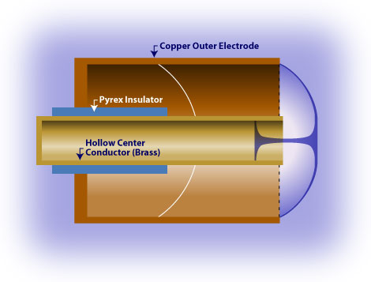
Figure 12 Dense plasma focus device. Image from Glenn Millam. Source: Focus Fusion Society
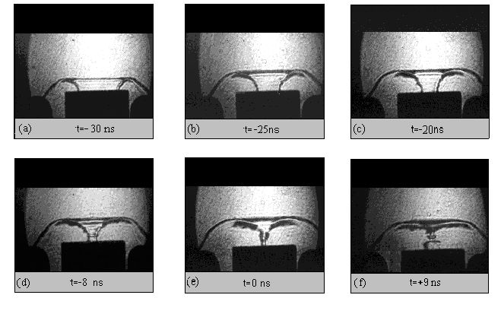

Figure 13. Shadowgraphic sequence showing formation of the plasma focus pinch

6.1. Scaling the plasma focus and neutron saturation

The plasma focus has shown great potential for developing into a fusion reactor. The plasma focus uses a first stage to match the risetime of a simple capacitor discharge, hus allowing the pinching stage to take place at peak current. Besides powerful bursts of x-rays, ion beams, REB’s and EM radiation, this simple mechanism has increased its fusion efficiency so that even a simple table top device is able to demonstrate significant nuclear fusion [9].

The plasma focus offers scalability as it has the same energy density per unit mass across the whole range of very small to very big devices, due to its requirements of the same speed factor (I/a)/p^{0.5} over the whole range of devices. The radiation yield is also predictable because of its scaling laws [11].

Its multiple radiations and beams enable it to be an excellent source for soft x-ray micro-lithography, micro-machining, materials processing, nanotechnology materials and a nuclear fusion source for energy [12-17].

Early experiments show that the fusion neutron yield is Y_{n}~E₀², i.e. proportional to the square of input energy [18]; so that break-even could be expected at several tens of MJ. However it was quickly shown that as E₀ approaches just 1 MJ (see Fig. 14) , the expected increase in neutron yield reduced and there appeared to be a tendency for the neutron yield to saturate [19]. The question now being asked: Is there a fundamental reason for neutron saturation [20] or is it just that the large plasma focus devices are not being properly operated.

Figure 14 Illustrating neutron saturation observed in measurements and in numerical experiments. The small black crosses are from numerical experiments. The large coloured crosses are from experiments. The straight line at low energies is Y_{n}~E₀²

6.2. Identifying the cause of neutron saturation

Extensive numerical experiments were carried out in the last 18 months using the Lee model code [21]; extending from very small plasma focus devices to the largest existing in the world to fix the base and reference lines for these experiments [22-25]. Then the numerical studies were extended [26] to devices as large as 25 MJ. The results show very clearly that neutron saturation is caused by a ‘motor’ effect. As mentioned earlier, all plasma focus are run at the same energy densities which means the same speeds. These give rise to the same ‘dynamic resistances’ which is of the order of 5 mOhm for every plasma focus, be it a 50 J device or one a million times larger at 50 MJ. Thus, operating the plasma focus at capacitor voltages 10-30 kV and with bank inductance around 20-40 nH, as all plasma focus are operated at, will lead to a situation where as bank capacitance is increased to 1000 uF, the bank surge (or short-circuit) impedance decreases to the level of 5 mOhm. At this point, which is around 0.5 MJ, the generator impedance is of the order of the load impedance (predominantly the dynamic resistance mentioned above). Further increase in bank energy by increasing capacitance leads to generator impedance reducing below the level of the load impedance, For example at 5 MJ, the capacitor bank surge impedance has dropped below 2 mOhm. Above 0.5 MJ and as bank energy gets bigger and bigger, the circuit current is more and more dominated by the constant dynamic resistance. At 30 kV, the current then tends towards an asymptotic value of 6 MA. This current saturation leads to neutron saturation [27].

6.3. Operating the plasma focus beyond neutron saturation- Ultra high voltage and current-steps

Now that we have identified the cause of the neutron saturation we may suggest a remedy to reach beyond saturation. There is nothing we can do about the dynamic resistance. It is there and is needed to provide the drive for the plasma. It cannot be reduced. What we need to do is to increase the voltage. For example if we use 300 kV capacitor banks instead of 30 kV, we will move the current saturation asymptotic value to 60MA. Thus plasma focus will have to move into a brave new world of high voltages. Technically there is already a precedence in the German SPEED II [28], a plasma focus designed to operate at 300 kV using Marx, parallel charging, series discharge technique. SPEED II was not tested as extensively as it could have been and is now operating at reduced voltages in Chile. The Marx bank used in SPEED II has a large generator impedance of 50 mOhm, which is then the dominant impedance during the axial phase, and itself limits the current to 6 MA. 300 kV banks with low impedance of the order of 5 mOhm will be more efficient in this situation and may deliver more current up to 30 MA into the plasma focus. The bank energy would be of the order of 2 MJ. Moving up to 1 MV may deliver currents up to 100 MA at tens of MJ.

Results of numerical experiments summarized in Fig 15 illustrate the diminishing fusion gain of increasingly larger plasma focus devices. Fig 16 shows dramatic improvement when ultra high voltage is used.

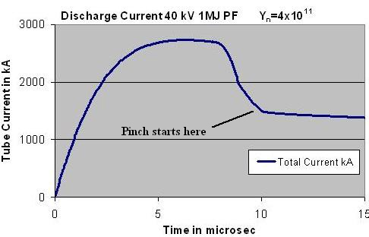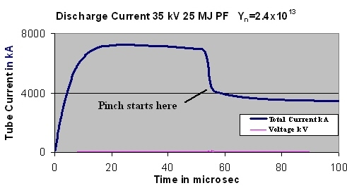
Figure 15 Comparing discharge current amplitudes and neutron yields as bank energy E₀ increases at constant voltage.
There is fall away from the ideal scaling law of Y_{n}~E₀²
[numerical experiments at IPFS & INTI UC May 2009, The 1 MJ PF of Fig 15 agrees with measurements
at the ICDMP on PF1000]]

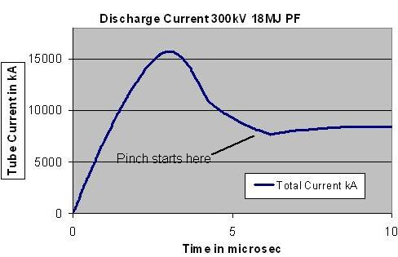
Figure 16. Discharge current reaches much larger values for less E₀ when operated at higher voltage.
The neutron yield for this shot is computed as 4x10¹⁴. [numerical experiment at IPFS & UNTI UC, May 2009]

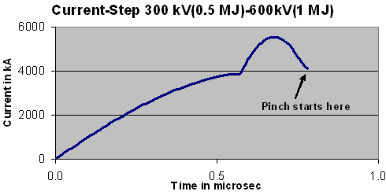
Figure 17. A current step can push the current value up at the crucial moment when the large pinch
‘dynamic resistance’ tends to drop the current. [numerical experiment at IPFS & INTI UC, July 2009]

Other techniques could be used to increase the current. During the radial phase, in particular, there is a sharp drop in current due to the sharp increase in dynamic resistance. By the time the radial implosion reaches the dense pinch phase the current has dropped by as much as 30-50% for the biggest devices. This drop in current occurs at the time when the current is most crucial, being needed to drive the pinch compression. A current-step would be very usefully applied at this time (see Fig 17) . At the University of Malaya we had experimented with such current steps in the ‘80s [29,30]. This technology is feasible. With the combination of low-impedance, high-voltage drivers and current-stepping technology, plasma focus would move into new regimes and once again regain momentum in the quest for fusion energy.

6.4. Plasma focus fusion reactor energy cycle

A schematic of a plasma focus fusion reactor may be as shown in the final figure.

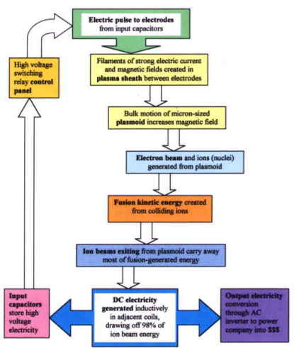

Figure 18 Illustrating the Plasma Focus Fusion Reactor Cycle: Focus Fusion Society

7. Conclusion

Tokamak-based nuclear fusion programmes are moving steadily towards harnessing plasma nuclear energy to provide clean, limitless energy for the continuing progress of civilization. Other smaller scale plasma fusion experiments will also have a role to play in this scientific and technological development, the most challenging and rewarding in the history of Mankind. In particular numerical experiments currently under intensive investigations are pointing the way to plasma focus research to go beyond present neutron saturation regimes; thus to regain momentum for this class of devices in the quest for fusion energy.

References:

[1] http://fusion.gat.com
[2] http://fire.pppl.gov
[3] http://www.jet.efda.org
[4] http://www.iter.org
[5] http://www.fusion.org.uk
[6] Meade, Dale. “50 Years of Fusion Research”, PPPL Colloquium, April 1, 2009, Princeton, NJ 08543
http://fire.pppl.gov/meade_PPPL_colloq_040109.pdf
[7] Lee, S and Gribkov, Vladimir A. “Cooperation with Small Countries in Plasma Science and Attempts to Apply to Industrial Needs”, ICTP/IAEA Workshop on Plasma Diagnostics and Industrial Applications of Plasmas, October 2000, ICTP Trieste. http://eprints.ictp.it/101/
[8] http://www.hiper-laser.org
[9] S. Lee, T. Y. Tou, S. P. Moo, M. A. Eissa, A. V. Gholap, K. H. Kwek, S. Mulyodrono, A. J. Smith, S. Suryadi, W. Usada, and M. Zakaullah, “A simple facility for the teaching of plasma dynamics and plasma nuclear fusion,” Amer. J. Phys., vol. 56, no. 1, pp. 62–68, Jan. 1988.
[10] S. Lee, in Twelve Years of UNU/ICTP PFF—A Review. Trieste, Italy: Abdus Salam ICTP, 1998, pp. 5– 34. IC/ 98/ 231, ICTP Open Access Archive. [Online]. Available: http://eprints.ictp.it/31/
[11] S. Lee and A. Serban, “Dimensions and lifetime of the plasma focus pinch,” IEEE Trans. Plasma Sci., vol. 24, no. 3, pp. 1101–1105, Jun. 1996. http://eprints.ictp.it/42/
[12] M Favre, S Lee, SP Moo, CS Wong X-ray emission in a small plasma focus operating with H2-Ar mixtures. Plasma Sources Science and Technology, 1992
[13 E P Bogolyubov, V D Bochkov, V A Veretennikov, L T Vekhoreva, V A Gribkov, A V Dubrovskii, Yu P Ivanov, A I Isakov, O N Krokhin, P Lee, S Lee, V Ya Nikulin, A Serban, P V Silin, X Feng and G X Zhang.
“A Powerful Soft X-ray Source for X-ray Lithography Based on Plasma Focusing” Physica Scripta, (1998) 57 488-494
[14] S. V. Springham, S. Lee, and M. S. Rafique, “Correlated deuteron energy spectra and neutron yield for a 3 kJ plasma focus,” Plasma Phys. Control. Fusion, vol. 42, no. 10, pp. 1023–1032, Oct. 2000.
[15] S V Springham, TL Tan, P Lee, M Zakaullah, S Lee “Spectral study of the electron beam emitted from a 3 kJ plasma focus” PLASMA SOURCES SCIENCE AND TECHNOLOGY, 2005 14, 549-560
[16] A. Serban and S. Lee, “Experiments on speed-enhanced neutron yield from a small plasma focus,” J. Plasma Phys., vol. 60, 3–15, Aug. 1998.
[17] LY Soh, P Lee, X Shuyan, S Lee, RS Rawat Shadowgraphic studies of DLC film deposition process in dense plasma focus device - IEEE Transactions on Plasma Science, 2004, 32, 448- 455
[18] Rapp H. “ Measurements referring to plasma focus scaling laws” 1973 Phys Lett A 43A 420-422
[19] Herold H, Jerzykiewicz A, Sadowski M, Schmidt H (1989) Comparative analysis of large plasma focus experiments performed at IPF, Stuttgart, and IPJ, Swierk. Nucl Fusion 29 1255–1260
[20] M. Scholz, Report at the ICDMP Meeting, ICDMP, Warsaw, Poland, November2007
[21] Lee S Radiative Dense Plasma Focus Computation Package: RADPF http://www.intimal.edu.my/school/fas/UFLF/
http://www.plasmafocus.net/IPFS/modelpackage/File1RADPF.htm
[22] S. Lee and S. H. Saw, “Neutron scaling laws from numerical experiments,” J. Fusion Energy, vol. 27, no. 4, pp. 292–295, Dec. 2008.
[23] S. Lee and S. H. Saw, “Pinch current limitation effect in plasma focus,”
Appl. Phys. Lett., vol. 92, no. 2, p. 021 503, Jan. 2008.
[24] S. Lee, P. Lee, S. H. Saw, and R. S. Rawat, “Numerical experiments on plasma focus pinch current limitation,” Plasma Phys. Control. Fusion, vol. 50, no. 6, Jun. 2008. 065 012 (8pp).
[25] S. Lee, S. H. Saw, P. C. K. Lee, R. S. Rawat, and H. Schmidt, “Computing plasma focus pinch current from total current measurement,” Appl. Phys.Lett., vol. 92, no. 11, p. 111 501, Mar. 2008.
[26] S. Lee, “Current and neutron scaling for megajoule plasma focus machines,” Plasma Phys. Control. Fusion, vol. 50, no. 10, p. 105 005 (14pp), Oct. 2008.
[27] S Lee “Diagnostics and Insights from Current waveform and Modelling of Plasma Focus” Keynote address presented at the International Workshop on Plasma Diagnostics and Applications, Singapore 2-3 July 2009 http://www.plasmafocus.net/IPFS/Papers/keynoteaddressIWPDA09.doc
[28] G Decker, W Kies, R Nadolny, P Röwekamp, F Schmitz, G Ziethen, K N Koshelev, Yu V Sidelnikov

Observations of soft x‐ray production in the speed 2 plasma focus

1996 Plasma Sources Sci. Technol. 5 112-118
[29] Saw S H 1991 Experimental studies of a current-stepped pinch PhD Thesis Universiti Malaya
[30] Lee S 1984 ‘A current-stepping technique to enhance pinch compression’ J Phys D: Appl Phys 17 733

