Research Results of Plasma Focus Numerical Experiments

S Lee^{1,2,3}, S H Saw^{2,4}
¹Institute for Plasma Focus Studies, 32 Oakpark Drive, Chadstone, VIC 3148, Australia
²INTI International University College, 71800 Nilai, Malaysia
³Nanyang Technology University, National Institute of Education, Singapore 637616
⁴University of Malaya, Kuala Lumpur, Malaysia

e-mail: leesing@optusnet.com.au

Abstract

The Lee Model couples the electrical circuit with plasma focus dynamics, thermodynamics, and radiation. A phenomenological beam-target neutron generating mechanism is included in the code to provide information on the neutron yield. The Lee Model is extensively used to design and simulate experiments. This paper provides an overview of recent published results from numerical experiments carried out using the Lee Model. The results are: (1) a previously unsuspected “pinch current limitation” effect; (2) the existence of an optimum L_{o} below which the pinch current and neutron yield of that plasma focus would not increase, but instead decreases; (3) a realistic neutron yield scaling with pinch current; and (4) an innovative tool to obtain the pinch current. A dominant thread running through the research papers is that the pinch current has to be distinguished from the discharge peak current in the analysis and scaling of plasma focus experiments.

1. Introduction
The Lee Model in its two-phase form was described in 1984 [1]. It was used to assist in the design and interpretation of several experiments [2–4]. An improved five-phase model and code incorporating finite small disturbance speed [5] and radiation coupling with dynamics assisted several projects [6–8] and was web published [9] in 2000 and in 2005 [10]. Plasma self-absorption was included [9] in 2007. It has been used extensively as a complementary facility in several machines, for example, UNU/ICTP PFF [2,6] the NX2 [7,8] NX1 [7] and DENA [11]. It has also been used [12] in other machines for design and interpretation including Soto’s sub-kilojoule plasma focus machines [13] FNII [14] and the UBA hard x-ray source [15]. Information obtained from the model includes axial and radial velocities and dynamics [1,7,11,12], soft x-ray (SXR) emission characteristics and yield [6-8,16], design of machines [13,16], optimization of machines, and adaptation to other machine types such as the Filippov-type DENA [11]. A study of speed-enhanced neutron yield [17] was also assisted by the Lee Model code.
A detailed description of the Lee Model is already available on the internet [9,10]. A recent development in the code is the inclusion of neutron yield using a phenomenological beam-target neutron generating mechanism [18] incorporated in the present RADPFV5.13 [19]. This improved model has been used to discover the pinch limitation effect [20], the existence of an optimum L_{o} below which the pinch current and neutron yield of that plasma focus would not increase, but instead decrease [21], a realistic neutron yield scaling with pinch current [22] and has been proven to be an innovative tool to obtain the pinch current [23].

2. The numerical experiments
Numerical experiments were carried out on plasma focus machines for which reliable current traces and neutron yields are available. The experiment was applied to several machines including the PF400, UNU/ICTP PFF, the NX2 and Poseidon. The PF1000 which has a current curve published at 27kV and Y_{n} published at 35kV provided an important point.

Keynote address delivered by S H Saw at International Conference on Plasma Computation and Applications IWPCA2008, Kuala Lumpur on 14 July 2008

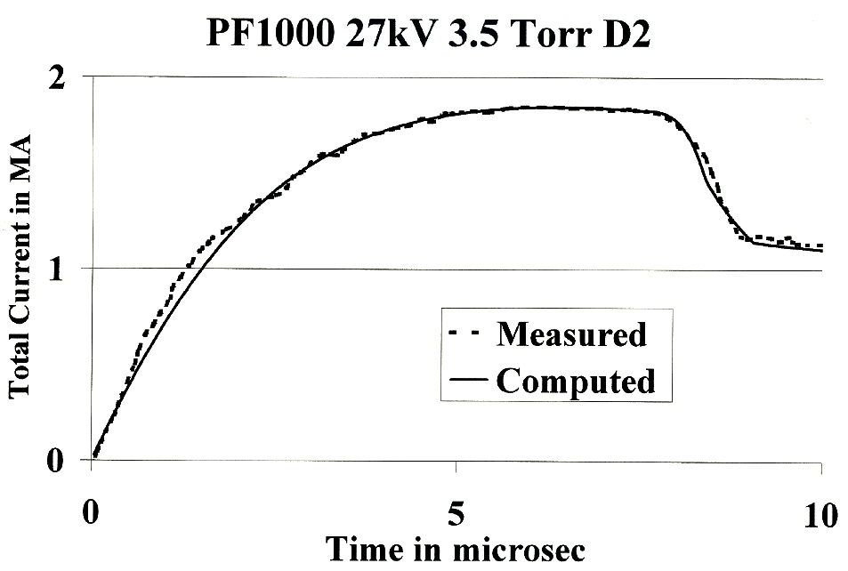
Figure 1. PF1000 at 27kV measured (dashed line) vs computed (smooth line) current traces.

Figure 1 shows a comparison of the computed total current trace (solid smooth line) with the experimental trace (dotted line) of the PF1000 at 27 kV at 3.5 Torr Deuterium, with outer/inner radii b=16 cm, a=11.55 cm, and anode length z_{o}=60 cm. In the numerical experiments we fitted external or static inductance L_{o}=33 nH and stray resistance r_{o}=6 mΩ with model parameters mass factor, current factor, and radial mass factor as f_{m}=0.14, f_{c}=0.7, and f_{mr}=0.35. The computed current trace agrees very well with the experiment, a typical performance of this code.
Each numerical experiment is considered satisfactory when the computed current trace matches the experiment in current rise profile and peak current, in time position of the current dip, in slope, and absolute value of the dip (see Figure 1). Once this fitting is done our experience is that the other computed properties including dynamics, energy distributions and radiation are all realistic.

3. Pinch current limitation effect
In a recent paper [18] there was expectation that the large MJ plasma focus PF1000 in Warsaw could increase its discharge current, and its pinch current, and consequently neutron yield by a reduction of its external inductance L_{o}. To investigate this point experiments were carried out using the Lee Model code [19]. Unexpectedly, the results indicated that whilst I_{peak} indeed progressively increased with reduction in L_{o}, no improvement may be achieved due to a pinch current limitation effect [20, 21]. Given a fixed C_{o} powering a plasma focus, there exists an optimum L_{o} for maximum I_{pinch}. Reducing L_{o} further will increase neither I_{pinch} nor Y_{n}.
We carried out numerical experiments for PF1000 using the machine and model parameters determined from Figure 1, modified by information about values of I_{peak} at 35 kV. Operating the PF1000 at 35 kV and 3.5 Torr, we varied the anode radius a with corresponding adjustment to b to maintain a constant c=b/a in order to keep the peak axial speed at 10 cm/μs. The anode length z_{o} was also adjusted to maximize I_{pinch} as L_{o} was decreased from 100 nH progressively to 5 nH.
As expected, I_{peak} increased progressively from 1.66 to 4.4 MA. As L_{o} was reduced from 100 to 35 nH, I_{pinch} also increased, from 0.96 to 1.05 MA. However, then unexpectedly, on further reduction from 35 to 5 nH, I_{pinch} stopped increasing, instead decreasing slightly to 1.03 MA at 20 nH, to 1.0 MA at 10 nH, and to 0.97 MA at 5 nH. Y_{n} also had a maximum value of 3.2x10¹¹ at 35 nH.
To explain this unexpected result, we examine the energy distribution in the system at the end of the axial phase (see Figure 1) just before the current drops from peak value I_{peak} and then again near the bottom of the almost linear drop to the pinch phase. The energy equation describing this current drop is written as follows:

0.5I_{peak}²(L_{o} + L_{a}f_{c} ²)= 0.5I_{pinch}² (L_{o}/ f_{c}² + L_{a} + L_{p}) + δ_{cap}+ δ_{plasma}, (1)

where L_{a} is the inductance of the tube at full axial length z_{o}, δ_{plasma} is the energy imparted to the plasma as the current sheet moves to the pinch position and is the integral of 0.5(dL/dt)I². We approximate this as 0.5L_{p}I_{pinch}² which is an underestimate for this case. δ_{cap} is the energy flow into or out of the capacitor during this period of current drop. If the duration of the radial phase is short compared to the capacitor time constant, the capacitor is effectively decoupled and δ_{cap} may be put as zero. From this consideration we obtain
I_{pinch}² = I_{peak}²(L_{o} + 0.5L_{a} )/(2L_{o} + L_{a} + 2L_{p}), (2)

where we have taken f_{c}=0.7 and approximated f_{c} ² as 0.5.
Generally, as L_{o} is reduced, I_{peak} increases; a is necessarily increased leading [17] to a longer pinch length z_{p}, hence a bigger L_{p}. Lowering L_{o} also results in a shorter rise time, hence a necessary decrease in z_{o}, reducing L_{a}. Thus, from Eq. (2), lowering L_{o} decreases the fraction I_{pinch} /I_{peak}. Secondly, this situation is compounded by another mechanism. As L_{o} is reduced, the L-C interaction time of the capacitor bank reduces while the duration of the current drop increases (see Fig 2, discussed in the next section) due to an increasing a. This means that as L_{o} is reduced, the capacitor bank is more and more coupled to the inductive energy transfer processes with the accompanying induced large voltages that arise from the radial compression. Looking again at the derivation of Eq. (2) from Eq. (1) a nonzero δ_{cap}, in this case, of positive value, will act to decrease I_{pinch} further. The lower the L_{o} the more pronounced is this effect.
Summarizing this discussion, the pinch current limitation is not a simple effect, but is a combination of the two complex effects described above, namely, the interplay of the various inductances involved in the plasma focus processes abetted by the increasing coupling of C_{o} to the inductive energetic processes, as L_{o} is reduced.

4. Optimum L_{o} for maximum pinch current and neutron yield
From the pinch current limitation effect, it is clear that given a fixed C_{o} powering a plasma focus, there exists an optimum L_{o} for maximum I_{pinch}. Reducing L_{o} further will increase neither I_{pinch} nor Y_{n}. The results of the numerical experiments carried out are presented in Figure 2 and Table 1.
With large L_{o} = 100 nH it is seen (Figure 2) that the rising current profile is flattened from what its waveform would be if unloaded; and peaks at around 12μs (before its unloaded rise time, not shown, of 18μs) as the current sheet goes into the radial phase. The current drop, less than 25% of peak value, is sharp compared with the current rise profile. At L_{o} = 30 nH the rising current profile is less flattened, reaching a flat top at around 5μs, staying practically flat for some 2μs before the radial phase current drop to 50% of its peak value in a time which is still short compared with the rise time. With L_{o} of 5 nH, the rise time is now very short, there is hardly any flat top; as soon as the peak is reached, the current waveform droops significantly. There is a small kink on the current waveform of both the L_{o} = 5 nH, z_{o} = 20 cm and the L_{o} = 5 nH, z_{o} = 40 cm. This kink corresponds to the start of the radial phase which, because of the large anode radius, starts with a relatively low radial speed, causing a momentary reduction in dynamic loading. Looking at the three types of traces it is seen that for L_{o} = 100 nH to 30 nH, there is a wide range of z_{o} that may be chosen so that the radial phase may start at peak or near peak current, although the longer values of z_{o} tend to give better energy transfers into the radial phase.

Figure 2. PF1000 current waveforms computed at 35kV, 3.5 Torr D2 for a range of L_{o}

The optimized situation for each value of L_{o} is shown in Table 1. The table shows that as L_{o} is reduced, I_{peak} rises with each reduction in L_{o} with no sign of any limitation. However, I_{pinch} reaches a broad maximum of 1.05MA around 40–30 nH. Neutron yield Y_{n} also shows a similar broad maximum peaking at 3.2 × 10¹¹ neutrons. Figure 3 shows a graphical representation of this I_{pinch} limitation effect. The curve going up to 4MA at low L_{o} is the I_{peak} curve. Thus I_{peak} shows no sign of limitation as L_{o} is progressively reduced. However I_{pinch} reaches a broad maximum. From Figure 3 there is a stark and important message. One must distinguish clearly between I_{peak} and I_{pinch}. In general one cannot take I_{peak} to be representative of I_{pinch}.
Table 1. Effect on currents and ratio of currents as L_{o} is reduced-PF1000 at 35kV, 3.5 Torr Deuterium
L₀(nH) | b(cm) | a(cm) | z₀(cm) | I_{peak}(MA) | I_{pinch}(MA) | Y_{n}(10¹¹) | I_{pinch}/ I_{peak}
100 | 15.0 | 10.8 | 80 | 1.66 | 0.96 | 2.44 | 0.58
80 | 16.0 | 11.6 | 80 | 1.81 | 1.00 | 2.71 | 0.55
60 | 18.0 | 13.0 | 70 | 2.02 | 1.03 | 3.01 | 0.51
40 | 21.5 | 15.5 | 55 | 2.36 | 1.05 | 3.20 | 0.44
35 | 22.5 | 16.3 | 53 | 2.47 | 1.05 | 3.20 | 0.43
30 | 23.8 | 17.2 | 50 | 2.61 | 1.05 | 3.10 | 0.40
20 | 28.0 | 21.1 | 32 | 3.13 | 1.03 | 3.00 | 0.33
10 | 33.0 | 23.8 | 28 | 3.65 | 1.00 | 2.45 | 0.27
5 | 40.0 | 28.8 | 20 | 4.37 | 0.97 | 2.00 | 0.22

Figure 3. Effect on currents and current ratio (computed) as Lo is reduced-PF1000, 35 kV, 3.5 torr D₂.

We carried out several sets of experiments on the PF1000 for varying L_{o}, each set with a different damping factor. In every case, an optimum inductance was found around 30–60 nH with I_{pinch} decreasing as L_{o} was reduced below the optimum value. The results showed that for PF1000, reducing L_{o} from its present 20–30 nH will increase neither the observed I_{pinch} nor the neutron yield, because of the pinch limitation effect.

5. Neutron yield scaling with pinch current
The main mechanism producing the neutrons is a beam of fast deuteron ions interacting with the hot dense plasma of the focus pinch column. The fast ion beam is produced by diode action in a thin layer close to the anode with plasma disruptions generating the necessary high voltages. This mechanism, described in some details in a recent paper [18], results in the following expression [22] used for the Lee Model code:
Y_{b-t}= calibration constant x n_{i}I_{pinch}² z_{p}² (ln(b/r_{p}))σ/V_{max}^{0.5} (3)

where I_{pinch} is the current at the start of the slow compression phase, r_{p} and z_{p} are the pinch radius and pinch length at the end of the slow compression phase, V_{max} is the maximum value attained by the inductively induced voltage and σ is the D-D fusion cross section (n branch) [24] corresponding to the beam ion energy. The D-D cross section σ is obtained by using beam energy equal to 3 times V_{max}, to conform to experimental observations [25].
Experimental data [26,27] of neutron yield Y_{n} against pinch current I_{pinch} is assembled (see Figure 4) to produce a more global scaling law than available. It must be noted that there is no clear distinction shown in the literature of I_{pinch} , I_{peak} and I_{total}. From the data a mid-range point is obtained to calibrate the neutron production mechanism of the Lee Model code (Figure 4).

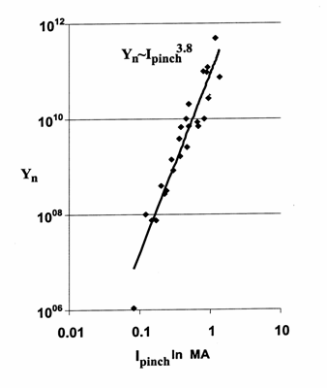
Figure 4. Assembly of experimental data to obtain Y_{n} scaling with current; loosely termed as the current or pinch current in the literature. This is the experimental curve from which a calibration point is obtained, at
0.5 MA, to calibrate the neutron yield equation (3) for the Lee Model code.

We then apply the calibrated code to several machines including the PF400, UNU/ICTP PFF, the NX2 and Poseidon to derive neutron scaling laws from computation. The PF1000 which has a current curve published at 27kV and Y_{n} published at 35kV provided an important point. Moreover using parameters for the PF1000 established at 27 kV and 35 kV, additional points were taken at different voltages ranging from 13.5kV upwards to 40kV. These machines were chosen because each has a published current trace and hence the current curve computed by the model code could be fitted to the measured current trace.

Table 2. Computed values of Ipeak, Ipinch & Yn and selected parameters for a range of Focus Machines
 | Machine | V_{o}  (kV) | P_{o}  (Torr) | L_{o}  (nH) | C_{o}  (μF) | b  (cm) | a  (cm) | Z_{o}  (cm) | I_{peak}  (MA) | I_{pinch}  (MA) | S | Y_{n} | k_{min} | I_{pinch}/  I_{peak}
 | PF400 | 28 | 6.6 | 40 | 0.95 | 1.55 | 0.60 | 1.7 | 0.126 | 0.082 | 82 | 1.1 x 10⁰⁶ | 0.14 | 0.65
 | UNU | 15 | 4 | 110 | 30 | 3.2 | 0.95 | 16 | 0.182 | 0.123 | 96 | 1.2 x 10⁰⁷ | 0.14 | 0.68
 | NX2 T | 15 | 5 | 20 | 28 | 5 | 2 | 7 | 0.386 | 0.225 | 86 | 2.5 x 10⁰⁸ | 0.16 | 0.58
 | Calibration | 16 | 5 | 24 | 308 | 7 | 4 | 30 | 0.889 | 0.496 | 99 | 5.6 x 10⁰⁹ | 0.17 | 0.56
 | NX2 T-2 | 12.5 | 10.6 | 19 | 28 | 3.8 | 1.55 | 4 | 0.357 | 0.211 | 71 | 2.4 x 10⁰⁸ | 0.16 | 0.59
 | PF1000 | 13.5 | 3.5 | 33 | 1332 | 8.00 | 5.78 | 60 | 0.924 | 0.507 | 89 | 9.6 x 10⁰⁹ | 0.17 | 0.55
 |  | 18 | 3.5 | 33 | 1332 | 10.67 | 7.70 | 60 | 1.231 | 0.636 | 89 | 2.9 x 10¹⁰ | 0.18 | 0.52
 |  | 23 | 3.5 | 33 | 1332 | 13.63 | 9.84 | 60 | 1.574 | 0.766 | 89 | 6.8 x 10¹⁰ | 0.19 | 0.49
 |  | 27 | 3.5 | 33 | 1332 | 16 | 11.60 | 60 | 1.847 | 0.862 | 89 | 1.2 x 10¹¹ | 0.19 | 0.47
 |  | 30 | 3.5 | 33 | 1332 | 17.77 | 12.80 | 60 | 2.049 | 0.929 | 89 | 1.6 x 10¹¹ | 0.20 | 0.45
 |  | 35 | 3.5 | 33 | 1332 | 20.74 | 15.00 | 60 | 2.399 | 1.037 | 89 | 2.7 x 10¹¹ | 0.20 | 0.43
 |  | 40 | 3.5 | 33 | 1332 | 23.70 | 17.10 | 60 | 2.736 | 1.137 | 89 | 4.1 x 10¹¹ | 0.21 | 0.42
 | Poseidon | 60 | 3.8 | 18 | 156 | 9.50 | 6.55 | 30 | 3.200 | 1.260 | 251 | 3.3 x 10¹¹ | 0.20 | 0.39

In Table 2, corresponding to each laboratory device, the operating voltage V_{o} and pressure P_{o} are typical of the device, as is the capacitance C_{o}. It was found that the static inductance L_{o} usually needed to be adjusted from the value provided by the laboratory. This is because the value provided could be for short-circuit conditions, or an estimate including the input flanges and hence that value may not be sufficiently close to L_{o}. The dimensions b (outer radius), a (anode radius) and z_{o} (anode length) are also the typical dimensions for the specific device. The speed factor S [17] is also included. All devices except Poseidon have typical S values. Poseidon is the exceptional high speed device in this respect. The minimum pinch radius is also tabulated as k_{min}= r_{p}/a. It is noted that this parameter increases from 0.14 for the smaller machines towards 0.2 for the biggest machines. The ratio I_{pinch}/I_{peak} is also tabulated showing a trend of decreasing from 0.65 for small machines to 0.4 for the biggest machines.

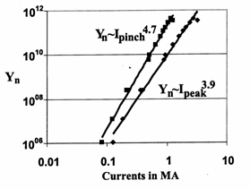
Figure 5. Computed neutron yield compiled to produce Y_{n}~I_{peak} and Y_{n}~I_{pinch} scaling laws

The results are the following: Y_{n}=2x10¹¹I_{pinch}^{4.7} and Y_{n}=9x10⁹I_{peak}^{3.9}; Y_{n} in units of neutrons per shot; and I_{peak} and I_{pinch} in MA.
It is felt that the scaling law with respect to I_{pinch} is rigorously obtained by these numerical experiments when compared with that obtained from measured data, which suffers from inadequacies in the measurements or assumptions of I_{pinch}.

6. Measurement of pinch current
The total current trace in a plasma focus discharge is the most commonly measured quantity. However, yield laws for plasma focus should be scaled to focus pinch current I_{pinch} rather than peak total current I_{peak}. Since the direct measurement of I_{pinch} is laborious and difficult, a reliable method for its deduction would be useful. Numerical experiments using the Lee Model code can be used to determine I_{pinch} from the total current trace of a plasma focus by fitting a computed current trace to the measured current trace. The method is applied to an experiment in which both the total current trace and the plasma sheath current trace were measured. The result shows good agreement between the values of computed and measured I_{pinch}.
We now describe how we tested the validity of this method. In an experiment in Stuttgart [28,29] using the DPF78, a Rogowski coil measured the I_{total} trace, and magnetic probes measured the plasma current I_{p} waveform. The bank parameters were C₀=15.6 μF (nominal) and L₀=45 nH (nominal), tube parameters were b=50 mm, a=25 mm, and z₀=150 mm, and operating parameters were V₀=60 kV, and P₀=7.6 Torr Deuterium. Figure 6 shows these measured I_{total} (labeled as I_{ges}) and I_{p} waveforms. The third trace is the difference of I_{total} and I_{p}.
These parameters were put into the code. The best fit for the computed I_{total} with the measured I_{total} waveform was obtained with the following: bank parameters were C₀ =17.2 μF, L₀=55 nH, and r₀=3.5 mΩ; tube parameters were b=50 mm, a=25 mm, and z₀=137 mm; and operating parameters were V₀=60 kV and P₀=7.6 Torr deuterium. Model parameters of f_{m}=0.06, f_{c}=0.57, f_{mr}=0.08, and f_{cr} =0.51 were fitted. With these parameters, the computed I_{total} trace compared well with the measured I_{total} trace, as shown in Figure 7. The computed dynamics, currents, and other properties of this plasma focus discharge were deemed to be correctly simulated.
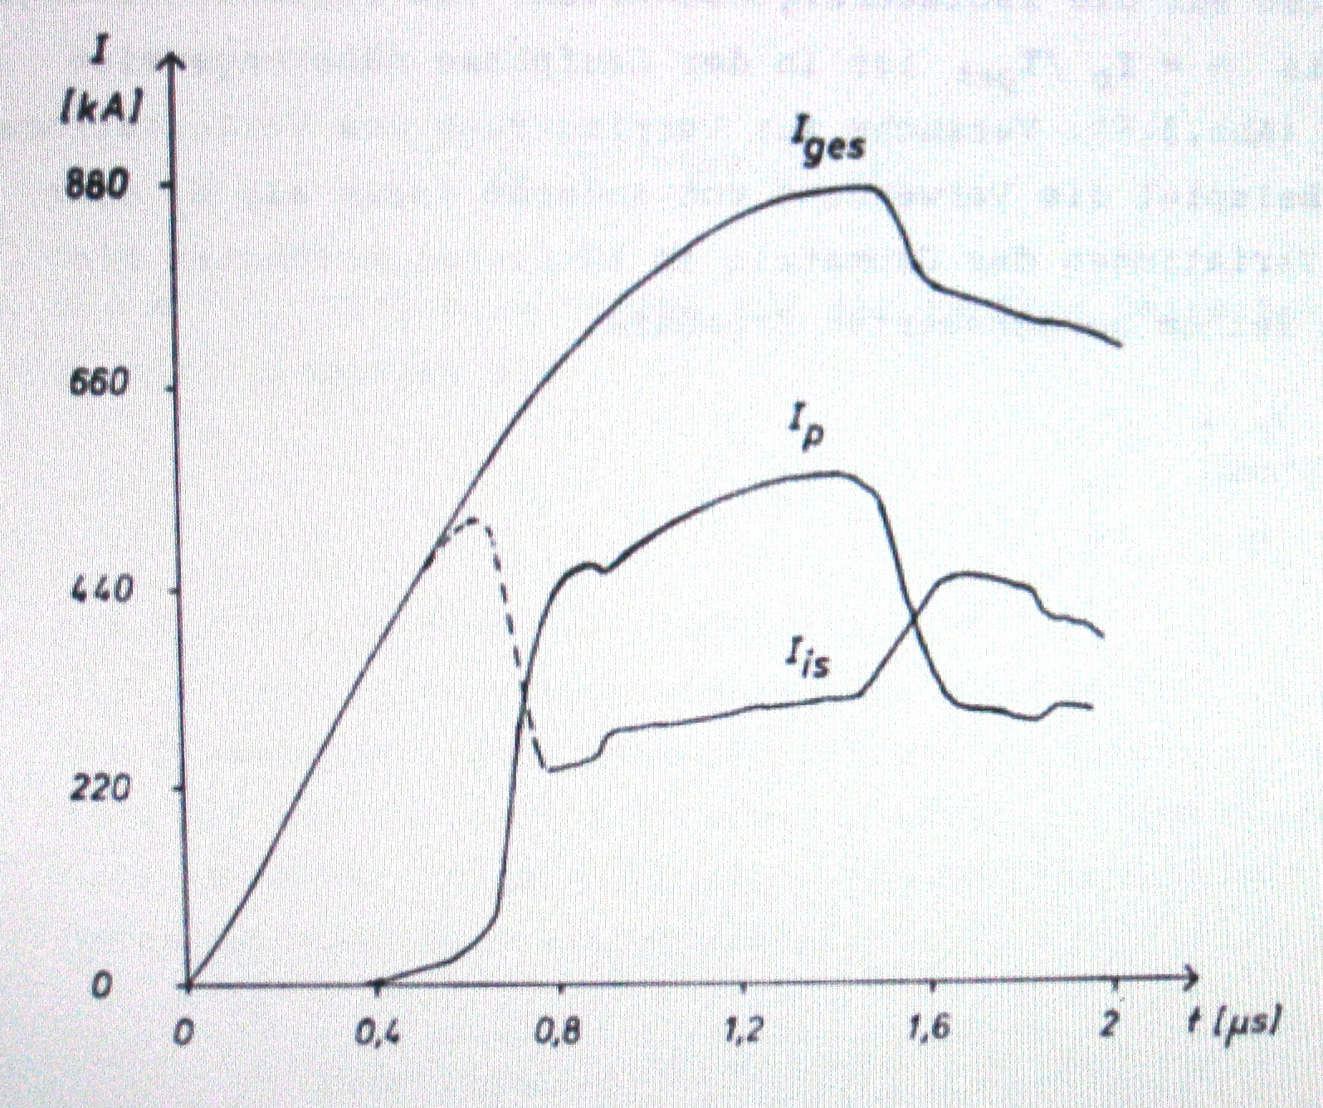
Figure 6. Experimental measurements of I_{total} (top trace) & I_{plasma} on DPF78 in Stuttgart.

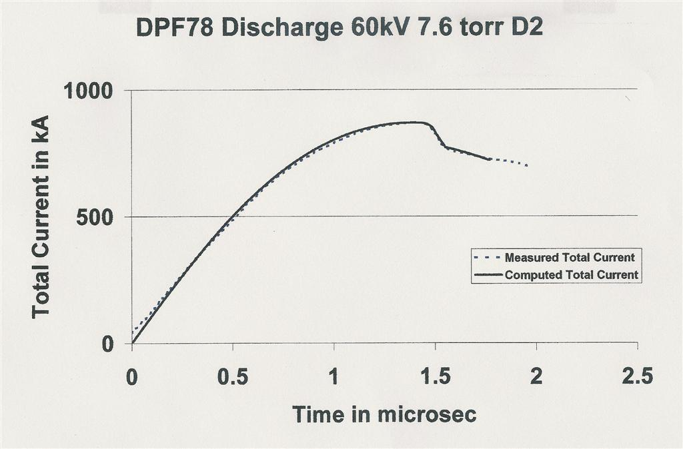
Figure 7. Fitting the computed I_{total} waveform to the measured I_{total} waveform from Fig 6

From the numerical experiments I_{pinch} was computed as 397 kA. I_{pinch} measured in the Stuttgart DPF78 experiment (Figure 6) was=381 kA. The computed I_{pinch} was 4% larger than the measured I_{pinch}. This difference was to be expected considering that the modeled f_{cr} was an average value of 0.51; while the laboratory measurement showed (Figure 8) that in the radial phase I_{p}/I_{total} varied from 0.63 to 0.4, and at the start of the pinch phase this ratio was 0.49 and rapidly dropping. Thus, one would expect the computed value of I_{pinch} to be somewhat higher than the measured, which turned out to be the case. Nevertheless, the difference of 4% is better than the typical error of 20% estimated for I_{pinch} measurements using magnetic probes. The numerical method proves to be a good alternative, being more accurate and convenient and only needing a commonly measured I_{total} waveform.

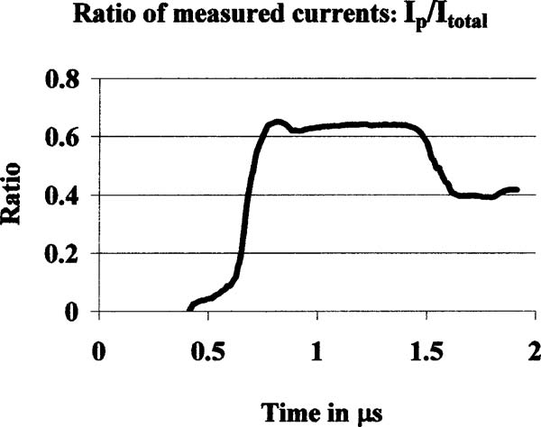
Figure 8. Ratio (measured) I_{p}/I_{total} derived from Figure 6.

7. Conclusion
The results of these numerical experiments indicate that corresponding to each plasma focus of capacitance C₀, there is an optimum value for L₀ below which performance in terms of I_{pinch} and Y_{n} does not improve. A scaling law Y_{n}~I_{pinch}^{4.7} is obtained from the numerical experiments. This numerically computed scaling is more rigorous and reliable than previously obtained scaling of Y_{n} with loosely termed 'pinch current'. This is because we have clearly defined and rigorously computed our pinch currents. It is worth emphasizing that one of the most important ideas arising from this series of published papers is the crucial need to differentiate between the commonly-measured I_{total} and the almost-never-measured pinch current I_{pinch} in attempts to understand plasma focus processes and scaling. The Lee Model code is a reliable tool to determine the pinch current.

References
[1] Lee S 1984 Radiations in Plasmas ed B McNamara (Singapore: World Scientific) pp 978–87
[2] Lee S et al 1988 Am. J. Phys. 56 62
[3] Tou T Y, Lee S and Kwek K H 1989 IEEE Trans. Plasma Sci. 17 311
[4] Lee S 1991 IEEE Trans. Plasma Sci. 19 912
[5] Potter D E 1971 Phys. Fluids 14 1911
[6] Liu M H, Feng X P, Springham S V and Lee S 1998 IEEE Trans. Plasma Sci. 26 135–40
[7] Lee S, Lee P, Zhang G, Feng X, Gribkov V A, Liu M, Serban A and Wong T 1998 IEEE Trans. Plasma Sci. 26 1119
[8] Bing S 2000 Plasma dynamics and x-ray emission of the plasma focus PhD Thesis NIE ICTP Open Access Archive: http://eprints.ictp.it/99/
[9] Lee S 2000/2007 http://ckplee.myplace.nie.edu.sg/plasmaphysics/
[10] Lee S 2005 ICTP Open Access Archive: http://eprints.ictp.it/85/
[11] Siahpoush V, Tafreshi M A, Sobhanian S and Khorram S 2005 Plasma Phys. Control. Fusion 47 1065
[12] Lee S 1998 Twelve Years of UNU/ICTP PFF—A Review IC, 98 (231) Abdus Salam ICTP, Miramare, Trieste; ICTP OAA: http://eprints.ictp.it/31/
[13] L. Soto, P. Silva, J. Moreno, G. Silvester, M. Zambra, C. Pavez, L. Altamirano, H. Bruzzone, M. Barbaglia, Y. Sidelnikov & W. Kies. Brazilian J Phys 34, 1814 (2004)
[14] H.Acuna, F.Castillo, J.Herrera & A.Postal. International conf on Plasma Sci, 3-5 June 1996, conf record Pg127
[15] C.Moreno, V.Raspa, L.Sigaut & R.Vieytes, Applied Phys Letters 89(2006)
[16] D.Wong, P.Lee, T.Zhang, A.Patran, T.L.Tan, R.S.Rawat & S.Lee. Plasma Sources, Sci & Tech 16, 116 (2007)
[17] S Lee & A Serban, IEEE Trans Plasma Sci 24, 1101-1105 (1996)
[18] Gribkov V A et al 2007 J. Phys. D: Appl. Phys. 40 3592
[19] Lee S Radiative Dense Plasma Focus Computation Package: RADPF http://www.intimal.edu.my/school/fas/UFLF/
[20] Lee S and Saw S H 2008 Appl. Phys. Lett. 92 021503
[21] S Lee, P Lee, S H Saw and R S Rawat. Plasma Phys. Control. Fusion 50 (2008) 065012
[22] Lee S and Saw S H Neutron scaling laws from numerical experiments J. Fusion Energy at press
[23] Lee S, Saw S H, Lee P C K, Rawat R S and Schmidt H 2008 Appl. Phys. Lett. 92 111501
[24] J.D.Huba. 2006 Plasma Formulary pg44
http://wwwppd.nrl.navy.mil/nrlformulary/NRL_FORMULARY_07.pdf
[25] S.V.Springham, S.Lee & M.S.Rafique. Plasma Phys Control.Fusion 42, 1023 (2000)
[26]W Kies in Laser and Plasma Technology, Procs of Second Tropical College Ed by S Lee, B.C. Tan, C.S. Wong, A.C. Chew, K.S. Low, H. Ahmad & Y.H. Chen , World Scientific, Singapore ISBN 9971-50-767-6 (1988) p86-137
[27] H Herold in Laser and Plasma Technology, Procs of Third Tropical College Ed by C S Wong, S. Lee, B.C. Tan, A.C. Chew, K.S. Low & S.P. Moo, World Scientific, Singapore ISBN 981-02-0168-0 (1990) p21-45
[28] T. Oppenländer: Ph.D. Dissertation, University of Stuttgart, Germany, 1981
[29] G Decker, L Flemming, H J Kaeppeler, T Oppenlander, G Pross, P Schilling, H Schmidt, M Shakhatre and M Trunk, Plasma Physics 22, 245-260 (1980)

